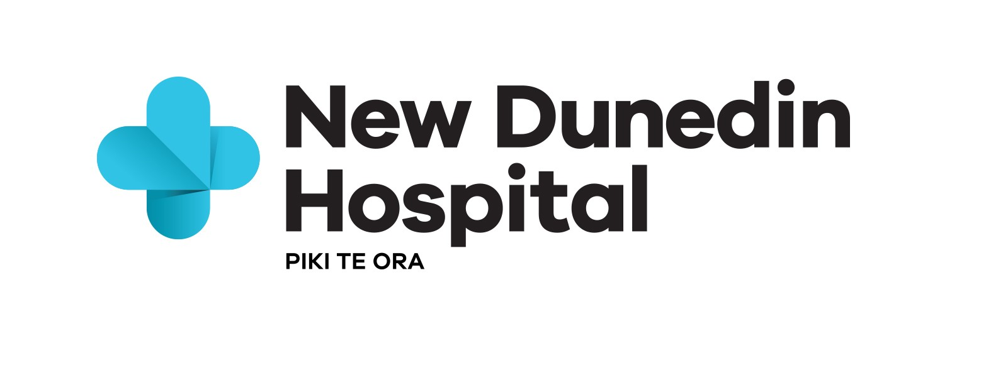

Request for Information Response Form

In response to the Request for Information
by: Southern DHB
for: Digital Solutions for New Dunedin Hospital
Date of this Registration: [insert date of this document]

- About the Respondent
  Supplier  tips | - The section gives the Buyer basic information about your organisation and identifies your Point of Contact for the duration of the RFI process.  - If an item is not applicable e.g. you do not have a registered office complete the box by stating ‘not applicable’.  - If you are submitting a joint or consortium Registration complete an ‘Our profile’ table for each Respondent. Cut and paste the table as appropriate. Provide only one Point of Contact for your joint/consortium Registration.

Our profile

Choose one of these statements to complete, and delete the others
This is a Registration of interest by [insert the name of your organisation] (the Respondent) alone to supply the Requirements.
OR This is a [joint/consortium] Registration of interest by [insert the name of your organisation] and [insert the name of the other organisation/s] (together the Respondents) to supply the Requirements.
General information
Item | Detail
Trading name: | [insert the name that you do business under]
Full legal name (if different): | [if applicable]
Physical address: | [if more than one office – put the address of your head office]
Postal address: | [e.g. P.O. Box address]
Registered office: | [if you have a registered office insert the address here]
Business website: | [url address]
Type of entity (legal status): | [sole trader / partnership / limited liability company or other entity / other please specify]
Registration number: | [if your organisation has a registration number insert it here e.g. company registration number]
Country of residence: | [insert country where you (if you are a sole trader) or your organisation is resident for tax purposes]
GST registration number: | [NZ GST number / if overseas please state]

Business Status
Item | Detail
Did the business originate in New Zealand (not being a New Zealand Subsidiary of an off-shore business) | [insert the name that you do business under]
Is the business majority owned or controlled by New Zealanders?
Is the principal place of business in New Zealand?
When was the business established?
List what Insurances (Public, Professional, Products) are held by the company, and for each please list the value Insured.

Our Point of Contact
Item | Detail
Contact person: | [name of the person responsible for communicating with the Buyer]
Position: | [job title or position]
Phone number: | [landline]
Mobile number: | [mobile]
Email address: | [work email]

- Response to the Request

Overview of our solution
Please provide an overview of your solution. For example, describe the technical aspects of the product and/or elements of the service offering.

- Product Information
Which ‘Digital Solution component/s’ (listed on page 13 of the RFI) do you see your products fitting within? (can be more than one)
[insert your answer here] maximum 100 words
Having considered the information in the RFI how do you see your product contributing to the Programme objectives?
[insert your answer here] – Maximum 2 pages
What key innovations can you provide which you believe are ‘cutting edge’ in the market?
[insert your answer here] – Maximum 1 page
- Reference sites
Please list at least one reference site and provide brief description of the role of the product/s within client systems. Ideally you will be able to provide contact details for each reference site (maximum of one page per reference site).
[insert your answer here] – Maximum 2 pages
- Capacity of the Respondent to deliver
Please provide an overview of the company structure, including locations and numbers of staff per location
[insert your answer here] - (max 100 words)
Has your company partnered with others in the past to deliver Digital Solutions? If so please describe this arrangement at a high level
[insert your answer here] - (max half a page)
Please describe the type of service support that would typically be provided during solution implementation in a Programme such as this. Southern DHB would like to understand how you would work with us to enable successful change and clear benefit realisation.
[insert your answer here] - (max one page)
Do you provide implementation and service support in house or in partnership with other companies (please summarise these)?
[insert your answer here] - (max half a page)
Please describe what type of proactive service support would typically be provided during life of product
[insert your answer here] - (max half a page)
Describe what type of reactive (urgent) support would typically be provided during life of product
[insert your answer here] - (max half a page)
- Procurement Processes
What information to you consider essential for the DHB to provide in upcoming Digital Solution Procurements? (max 100 words)
[insert your answer here] - (max 100 words)
What information to you consider preferential for the DHB to provide in upcoming Digital Solution Procurements?
[insert your answer here] - (max 100 words)
What response timeframe would be desirable for digital solution procurements?
[insert your answer here] - (max 100 words)
For a high value product would you be willing and able to engage with the DHB via a competitive dialogue procurement process? https://www.procurement.govt.nz/assets/procurement-property/documents/guide-competitive-dialogue.pdf
[insert your answer here] - (max 100 words)
What would your preference or standard be for ownership of Intellectual Property generated through provision of the services? (max 100 words)
[insert your answer here] - (max half a page)
What do you see as the biggest potential barrier to entry for you?
[insert your answer here] - (max half a page)
Would you be interested in attending meet the buyer or industry briefing type sessions? If so, would your preference be remote or in person attendance?
[insert your answer here] - (max 100 words)
Are you a member of Industry associations (and if so please list)
[insert your answer here] - (max 100 words)

