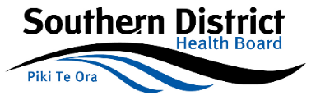
Mental Health, Addictions, and Intellectual Disability Directorate

Mental Health Outcomes, Systems, and Information
Overarching Philosophy
Mental Health Outcomes, Systems, and Information (MHISO) supports the Southern District Health Board (SDHB) Mental Health, Addiction and Intellectual Disability Service (MHAID) and it’s underpinning frameworks:
- Rising to the Challenge: The Mental Health and Addiction Service Development Plan 2012- 2017.
- SDHB Vision and Southern Way: Better Health, Better Lives, Whanau Ora.
- Raise HOPE – Hapaia te Tumanoko 2012 – 2015:

- More people with mental illness and or addictions will have good physical health.
- More people with mental illness and or addiction experience recovery.
- The health and wellbeing of the community is improved.
- Family Whanau are better enabled to support themselves and their family whanau.
- Fewer people will be affected by the misuse of alcohol and drugs.
Performed by an appropriately qualified Health Care Professional, with sufficient proficiency regarding Health and/or Nursing Informatics, MHISO seeks to uphold the above principles to support and enhance consumer and family whanau wellness and outcomes, sector-wide clinical services and clinical interventions; specifically by:
- Supporting the development and use of outcomes information.
- Supporting benchmarking (national KPI programme).
- Supporting clinical utility of MHISO.
- Supporting the use of information for research.
- Supporting clinical reporting that informs interventions and clinical services.
- Oversight and support of clinical training with respect to MHISO.
- Supporting local, regional, and national operational and clinical projects.
- Ensuring the highest level of data integrity and completeness both locally and nationally.
- Ensuring clinical systems are maintained and developed to effectively support clinical services.
- Supporting the MHAID clinicians, teams, service managers and leaders.
- Maintaining and developing effective linkages within the MHAID service and across the sector.
- Ensuring that personal knowledge and skills are maintained and enhanced.
- Adhering to national reporting requirements, primarily PRIMHD (Programme for Integration of Mental Health Data).

MHISO adheres to continued quality improvement that supports the Southern District Health Board’s Performance Excellence and Quality Improvement Strategy; identifying a cycle that supports clinical service development and maintenance.

The MHISO Quality Improvement Cycle consists of:

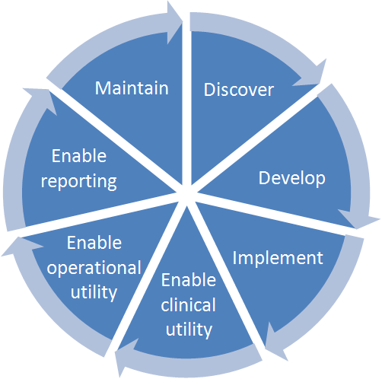
- Discovery
- Development
- Implementation
- Operational utility enablers
- Clinical utility enablers
- Reporting enablers
- Maintenance

Health Informatics
Health Informatics promotes the understanding, integration, and application of information technology in healthcare settings. This helps to ensure adequate and qualified support of clinician objectives and industry best practices. Health informaticians transform health care by analysing, designing, implementing, and evaluating information and communication systems that enhance individual and population health outcomes, improve patient care, and strengthen the clinician-patient relationship (HIMSS Healthcare Information and Management Systems Society, 2016. www.himss.org).

Nursing Informatics

Nursing informatics (NI) is the specialty that integrates nursing science with multiple information management and analytical sciences to identify, define, manage, and communicate data, information, knowledge, and wisdom in nursing practice. NI supports nurses, consumers, patients, the interprofessional healthcare team, and other stakeholders in their decision-making in all roles and settings to achieve desired outcomes. This support is accomplished through the use of information structures, information processes, and information technology (HIMSS Healthcare Information and Management Systems Society, 2016. www.himss.org).

Professional Practice Competencies

Drawing upon NZ Nursing Council ‘Competencies for Registered Nurses’ 2007, the following competencies can be applied to Health Informatics and to those involved in Mental Health Information, Systems and Outcomes within MHAID, Southern DHB:

Competency 2.3 - Ensures documentation is accurate and maintains confidentiality of information:
- Maintains clear, concise, timely, accurate and current health consumer records within a legal and ethical framework.
- Demonstrates literacy and computer skills necessary to record, enter, store, retrieve and organise data essential for care delivery.

Competency 2.9 - Maintains professional development.
- Contributes to the support, direction and teaching of colleagues to enhance professional development.

Competencies for nurses involved in management:
- Promotes a quality practice environment that supports nurses’ abilities to provide safe, effective and ethical nursing practice.
- Promotes a practice environment that encourages learning and evidence-based practice.
- Participates in professional activities to keep abreast of current trends and issues in nursing.

Competencies for nurses involved in education:
- Integrates evidence-based theory and best practice into education activities.
- Participates in professional activities to keep abreast of current trends and issues in nursing.

Competencies for nurses involved in research:
- Promotes a research environment that supports and facilitates research mindedness and research utilisation.
- Supports and evaluates practice through research activities and application of evidence based knowledge.
- Participates in professional activities to keep abreast of current trends and issues in nursing.

Competencies for nurses involved in policy:
- Utilises research and nursing data to contribute to policy development, implementation and evaluation.
- Participates in professional activities to keep abreast of current trends and issues in nursing.

Competency 4.1 - Collaborates and participates with colleagues and members of the health care team to facilitate and coordinate care.
- Promotes a nursing perspective and contribution within the interprofessional activities of the health care team.
- Collaborates with the health consumer and other health team members to develop plan of care.
- Maintains and documents information necessary for continuity of care and recovery.
- Develops a discharge plan and follow up care in consultation with the health consumer and other members of the health care team.

Competency 4.2 - Recognises and values the roles and skills of all members of the health care team in the delivery of care.
- Contributes to the co-ordination of care to maximise health outcomes for the health consumer.
- Collaborates, consults with and provides accurate information to the health consumer and other health professionals about the prescribed interventions or treatments.
- Demonstrates a comprehensive knowledge of community services and resources and actively supports service users to use them.

Competency 4.3 - Participates in quality improvement activities to monitor and improve standards of nursing.
- Reviews policies, processes, procedures based on relevant research.
- Recognises and identifies researchable practice issues and refers them to appropriate people.
- Distributes research findings that indicate changes to practice to colleagues.

Specific systems and aspects

The following systems and aspects are identified by MHAID as the core components with which those involved in Mental Health Information, Systems, and Outcomes participate:

- Patient Management System (iPM) including core patient demographics, referral, activity, caseload information.
- Outcomes collection (HoNOS and ADOM).
- Psychosocial information collection (Social Indicators, KPP).
- Psychiatric diagnosis collection.
- Medication administration and maintenance (Medchart).
- Ward management (Trendcare).
- Patient clinical records, workflow, forms, and documents (Health Connect South).
- SDHB reporting services and functions.
- PRIMHD interfaces

Author: Darren Smith | Mental Health Information, Systems, and Outcomes Site Coordinator, Mental Health, Addictions, and Intellectual Disability Service | Southern DHB

