Orion MedMan MedRec Process Proposal
Process:
- Access Medication widget

- Medications Summary appears
- Discharge meds from previous TOC will be listed here
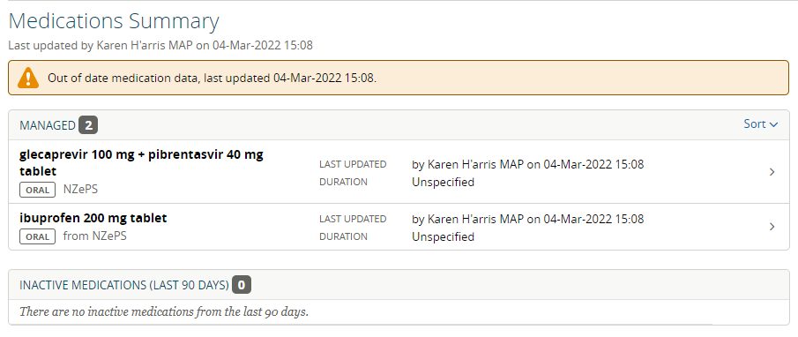
- Start a new Full Review
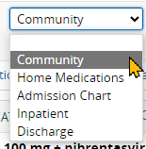
- Discard previous review if appropriate.
- Five types of reviews available:
  - Community
Started by nurse or dr at pre-admission; not linked to an episode
  - Home Medications
Done by Pharmacist: BPMH
  - Admission Chart
Pharmacist:compares with inpatient chart and indicates any discrepancies.
  - Inpatient
Pharmacist: reconciles medication (“Continue”) that is the same on inpatient chart. If any discrepancies to be reconciled, prescriber to be notified to complete review and reconciliation.
Dr.: review and reconcile where required. Update Medications Summary and Inpatient Meds Chart.
  - Discharge
Dr to list discharge medication and select meds for prescriptions

Community Review
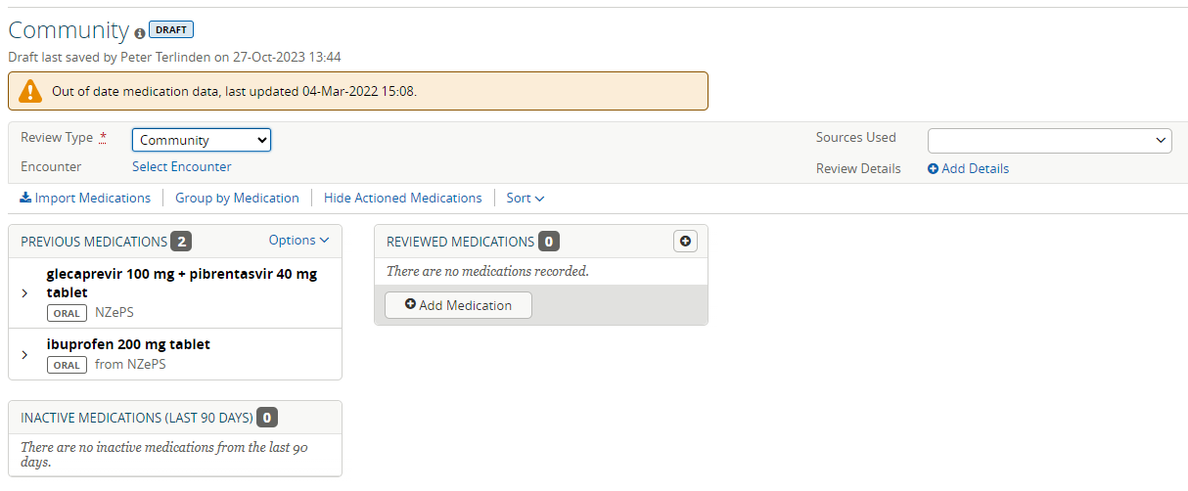

Import NZePS meds if required:
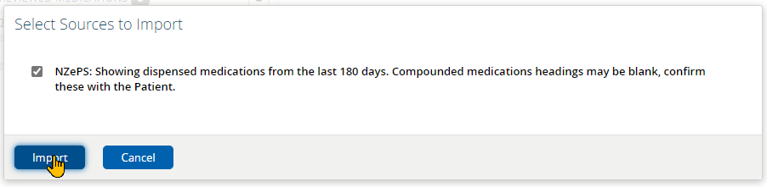
- NZePS Instructions coming through as unstructured text.
- When TP dispensed, medication is added to list as MP.
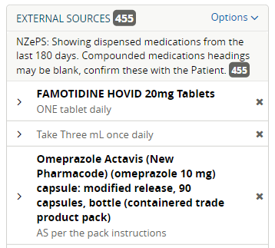
- Complete review by selecting and adding applicable meds
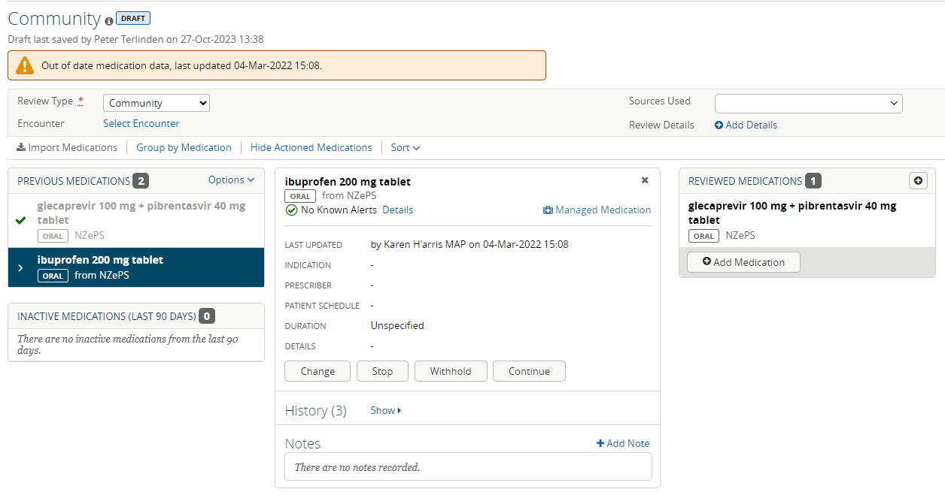
Review result:
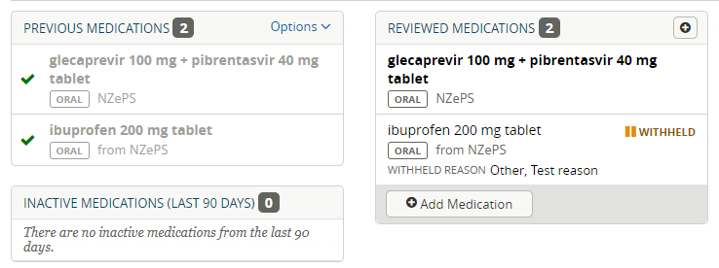
When Completed, this will result in an updated Medications Summary:
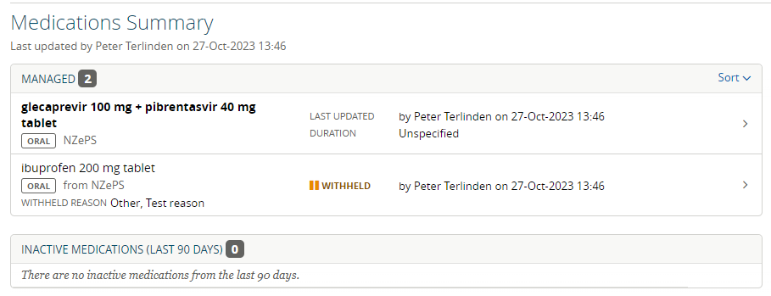

Home Medications Review
- Done by Pharmacist.
- Creating Best Possible Medication History (BPMH).
- Medication Summary (from Community Review) is listed for review.
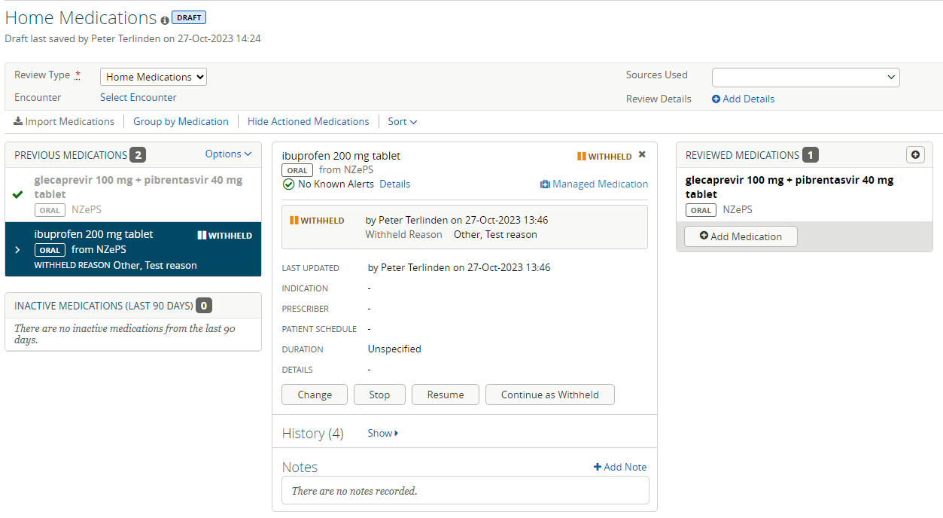
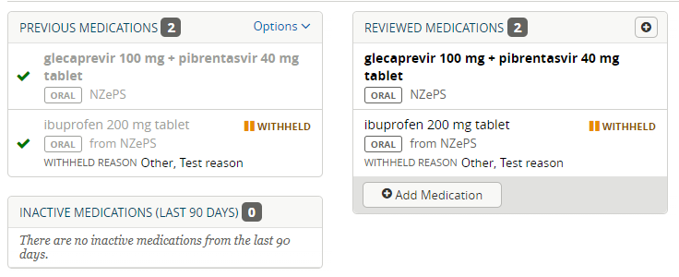
Result is updated Medications Summary:
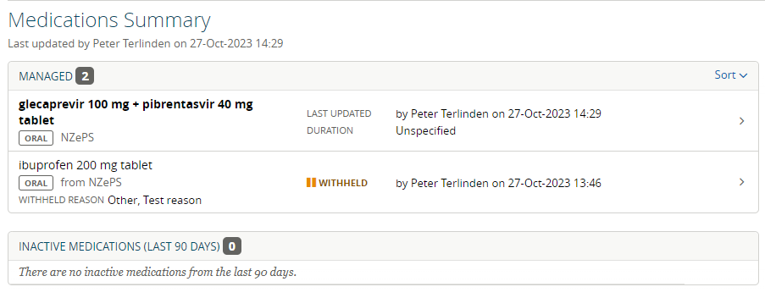

Admission Chart Review

- Done by Pharmacist
- Compare to inpatient medication chart
- Review and indicate any differences
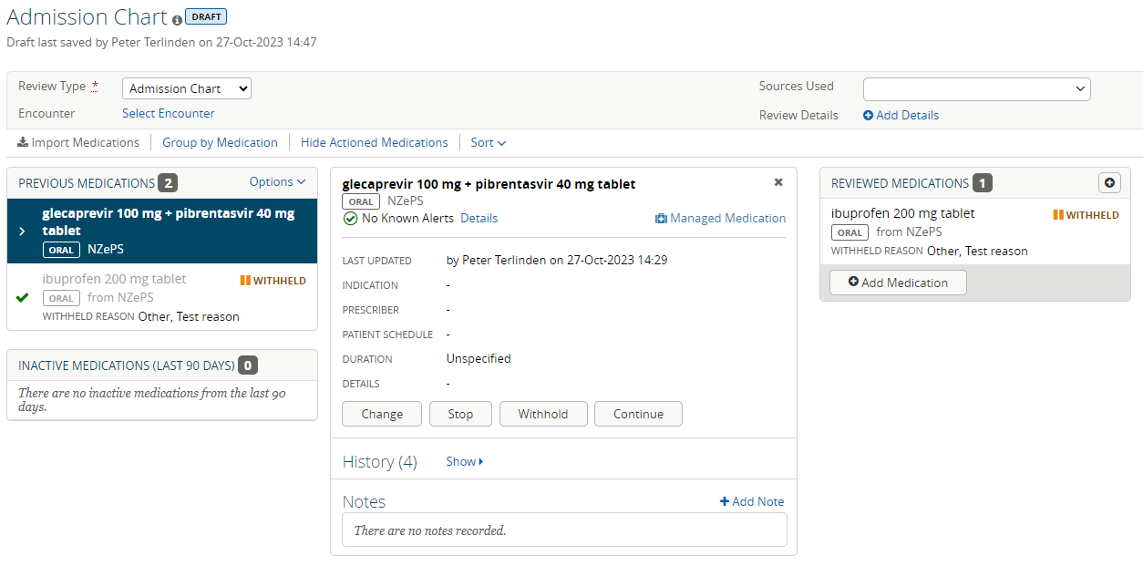

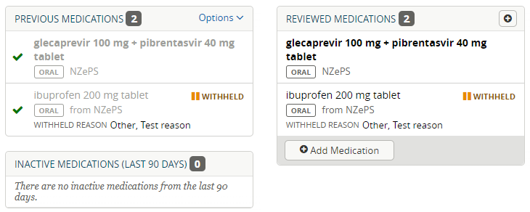
Result is updated Medications Summary:
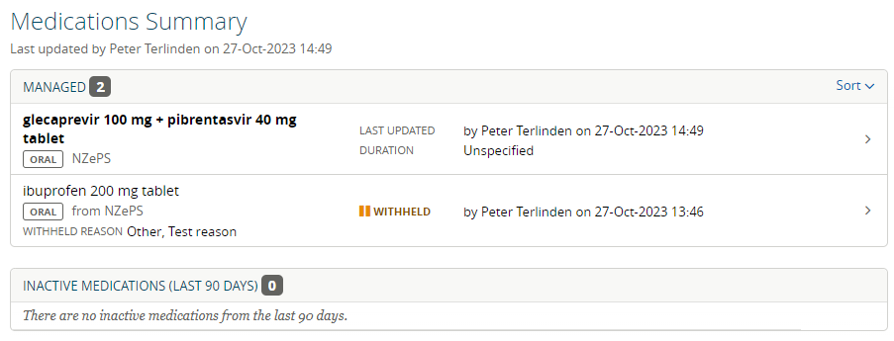

Inpatient Review

- Pharmacist reconciles all medications that are correct on the inpatient chart.
- Any remaining discrepancies need to be communicated to prescriber.
- Prescriber verifies discrepancies and reconciles the medication list and the inpatient medication chart.

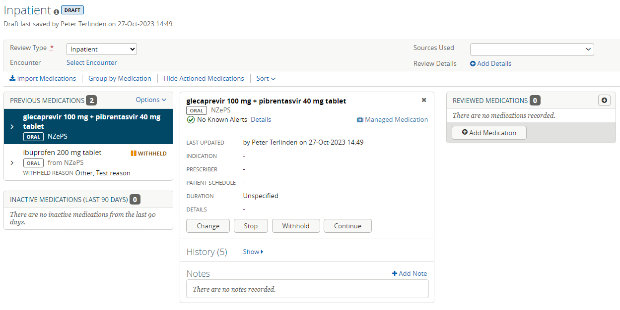
Results in another updated Medications Summary.

Discharge Review

- To be completed by prescriber.
- Can be done in Discharge Review screen or directly in the TOC.
- Process the same as other reviews.
- List is automatically updated in TOC.

List History
- Review Discharge list and compare to Home Medications list (BPMH).
- Any changes are highlighted, e.g. Added, Stopped, Changed.

Script

- Prescibe medicaton by dr.
- Print out script (or send to Broker)
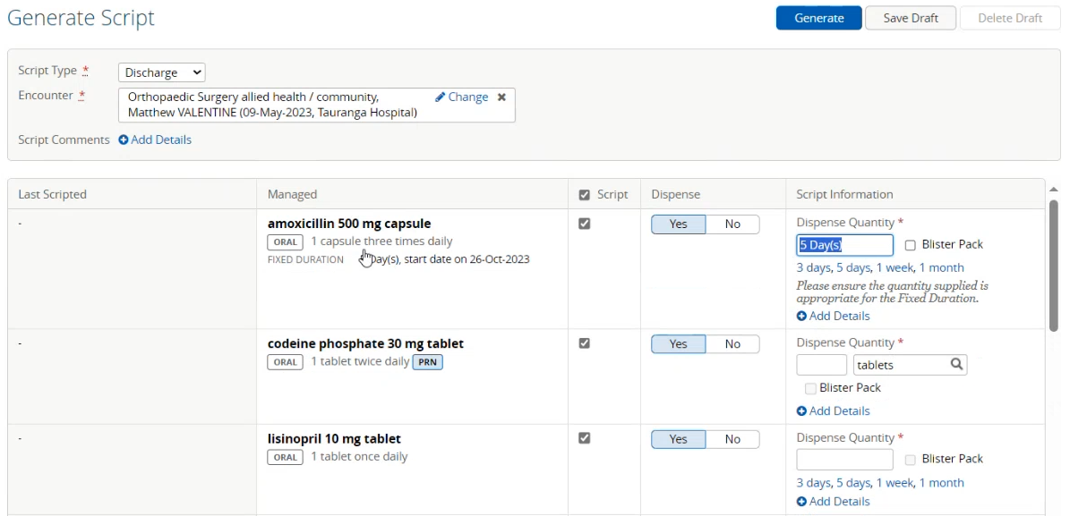
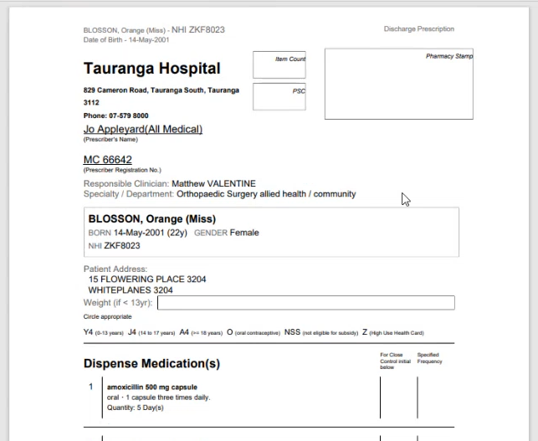

Schedule

- Print out medications schedule for patient.
- Unable to customise instructions.
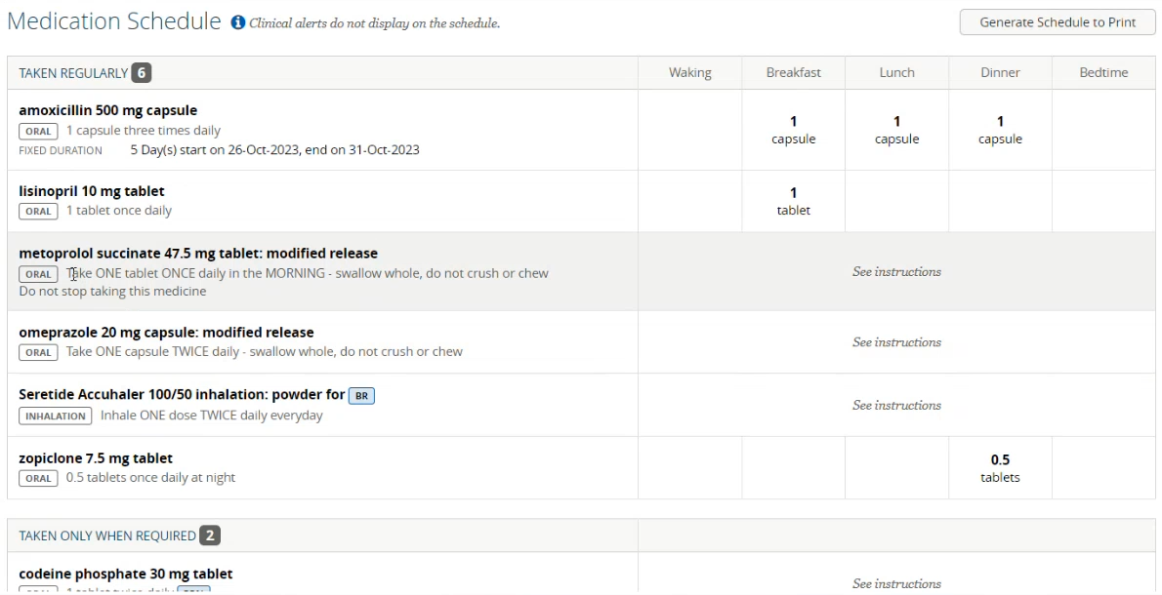

Suggested New MedRec Flow

- Home Medications Review
  - Nurse/Dr. enter pre-admission meds.
  - Form is saved as Draft
- Home Medication Review
  - Pharmacist imports NZePS list
  - Pharmacist gets BPMH list
  - Form is saved as Completed
- Inpatient Review
  - Pharmacist verifies list against Inpatient Medication Chart
    - If no discrepancies, saves list as Completed
    - If discrepancies, indicate discrepancies and notify prescriber and save list as Draft
- Inpatient Review
  - Prescriber reconciles discrepancies
  - Form is saved as Completed
- Discharge Form
  - Prescriber reconciles discharge meds
- List History
  - Prescriber verifies against other lists
- Script
  - Where required, prescriber generates script for dispensed meds
- Schedule
  - Pharmacist completes Meds Schedule for patient.
  - Pharmacist prints out Schedule for patient.

Gap List
No. | Gap | Mitigation/Solution | Remarks
1 | Full prescribing and dispensing history will need to be viewed through NZePS/MDR and can be done through a docked window (in patient context). | Access the NZePS tab in rCP for further information.
2 | Ability to import medication within the last seven months should be included in the Medications Summary list – Medication prescribed on e.g. a yearly base (outside the seven months) need to be reviewed through rCP NZePS/MDR. | Set import time frame to last seven months.
3 | Import from NZePS is Dispensed meds only, not Prescribed meds. | User can check in rCP for all prescribed and dispensed orders.
4 | Note added in review not showing in list or in prescription (change reason). However, it does show in the TOC under “Changes”. | Log as bug with Orion.
5 | No option to register discrepancies for:  - Unintended  - Not documented
6 | Unable to customise the table in the Schedule (“Yellow Card”) for the patient. Need to update script for appropriate text. | Current version acceptable?
7 | No list of all meds and no summary of meds changes on the script.
8 | Decision on how many forms (and form names) are required for MedRec process  - Home Medication List  - Inpatient List  - Discharge List
9 | Indications for non-completed MedRecs are required (e.g. “Inpatient review not or partial completed” or “still in draft”).
10 | If selected an encounter with a review, this should automatically populate in the next review.
11 | No check box for allergy checking. | Can be added to form.
12 | Quick List capability needs to get turned on. | Check with Orion. Fees?
13 | Option for Quick Text available but needs to be turned on – is currently being discussed at Regional level, as a fee is required for switching on this functionality.
14 | Need for recording actions for audit purposes. | What are the minimum audit requirements?
15 | Need for reporting. Verify which reports are required at a minimum. | What are the minimum reporting requirements?
16 | Need for displaying MedChart allergies. Need script to retrieve allergies from MedChart application.
17 | There is no pro-active notification for a prescriber where a reconciliation is required, or where the prescriber requires comms with the pharmacist.  - Alert Dr to creation of MedRec  - Alert and communicate discrepancies  - Alert and communicate with pharmacy that discrepancies have been addressed/not addressed  - Capture the data in an auditable form so that pharmacy is not transcribing the same information 4 times. Clinical notes, within the MedREc, through the communication of discrepancies, and then to pharmacy KPI /documentation
18
19
20

