Taranaki Medication Reconciliation Process and Forms

High Level Requirements
- Collect a Best Possible Medication History (BPMH)
  - NZePS feed (prescribed and dispense medication)
  - Transcribe and create an Admission list of medicines.
  - Verify with 2 or more sources patient, GP, pharmacy, etc.

- Compare BPMH list with the currently prescribed medication.
  - Indicate any discrepancies.
    - Verify intended/unintended.
    - Verify documented/not documented.
    - If no discrepancies, finalise BPMH list.
  - If discrepancies, communicate with prescriber.
    - If discrepancies, prescriber to reconcile list.

- Communicate DMCS (Discharge Medication Changes Summary) to primary health care by way of Discharge Summary and on the prescription to the pharmacy.
  - Create discharge medication list.
    - Reconcile current admission medicines against the inpatient charted medication and any additional meds at discharge.
      - Creates a Discharge Medication Changes Summary (DMCS) – clearly indicating if changes have been made and why.
      - Indicate any meds for dispense (new / changes meds should auto-populate for requiring a prescription.
    - Print/send prescription for those medicines to be dispensed.

Taranaki Medication History Form

Remarks

- User can select patient location - should come from episode HL7 message?
- Allergies coming from MedChart
- Option to enter exact number of allergies for double checking
- Pharmacy info
  - Coming from local PAS
  - List of Taranaki pharmacies
- Option to Save and Finish form
- Elements in form get checked
- Spell check on form
- Option to amend
- Data transferred from Admission Note?

Draft Form
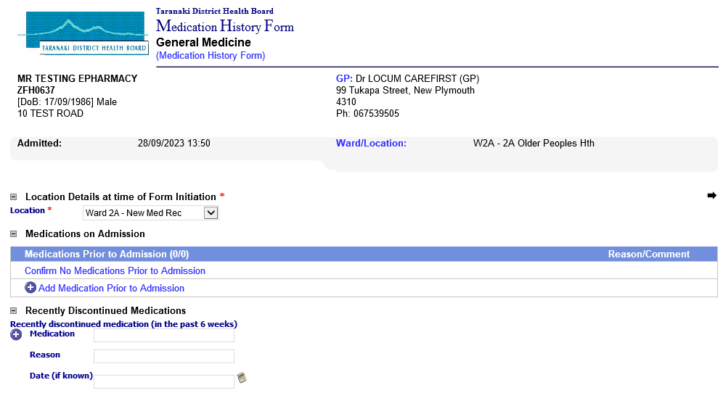
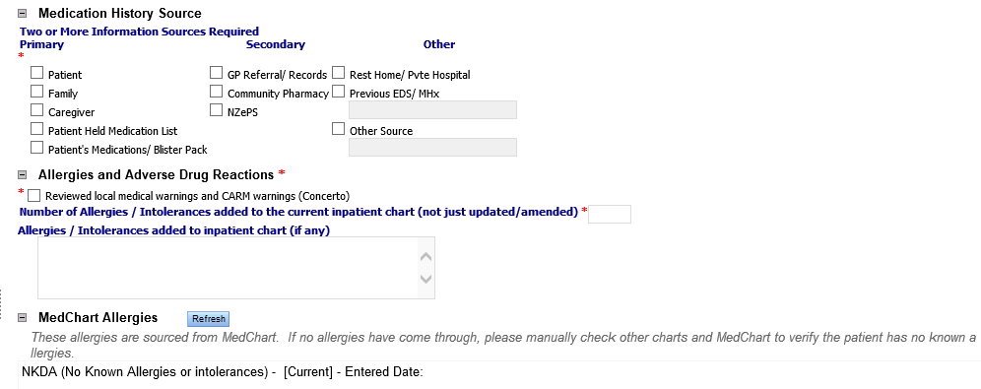
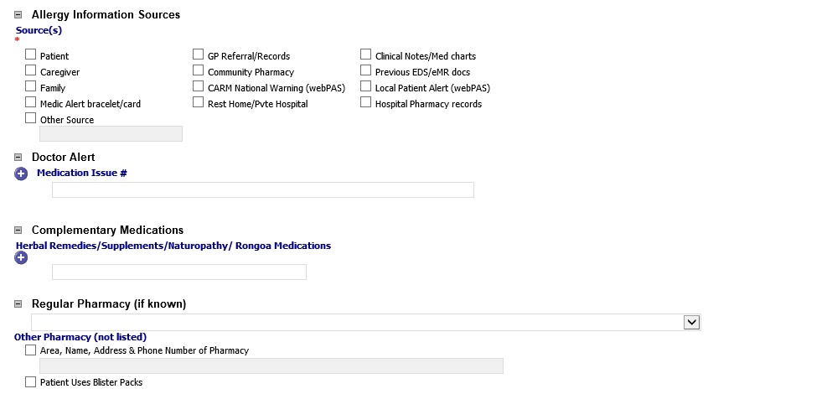
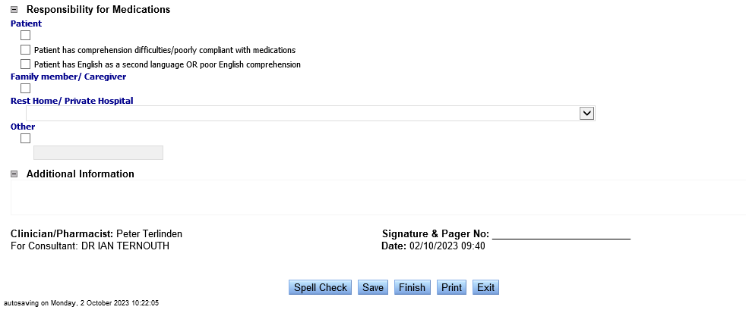

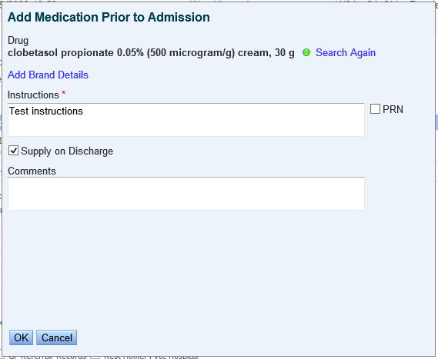

Finalised form
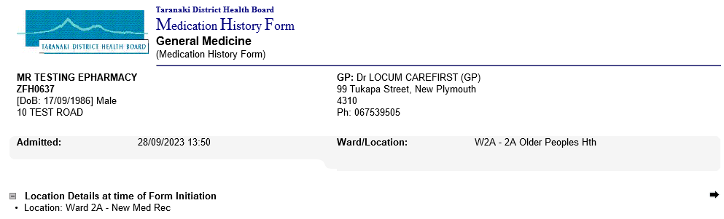
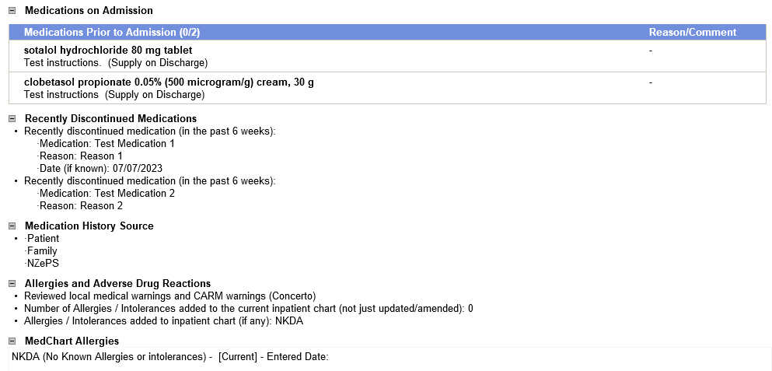
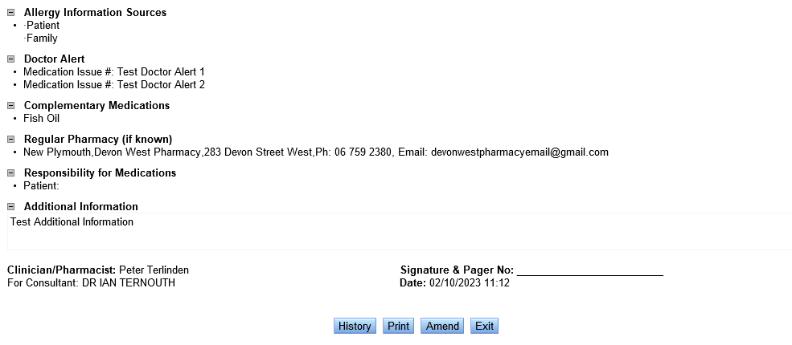

Taranaki Medication Reconciliation Form

Remarks
- Data transferred from Medication History Form:
  - Doctor Alert
  - Medications Prior to Admission
  - Allergies entered manually
  - Allergy Information Sources
  - Complementary Medications
  - Regular or other pharmacy
  - Responsibility for Medications
  - Additional information
- MedChart allergies imported.
- If no Meds History form done earlier, warning message.
- Option to edit/remove medications from Medications Prior to Admission list
- Reconciliation options
  - Same/Different
  - If Same - "Same as chart" with meds name
  - If Different - Intended/Unintended + Go Back option
  - If Intended - Stopped/Changed/Withheld
    - If Stopped - Enter Reason
    - If Changed - Update meds details
- Option to add medication Started After Admission

Draft form
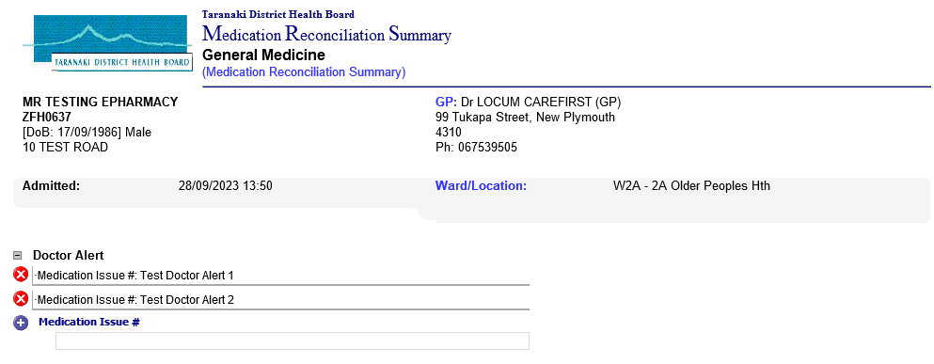
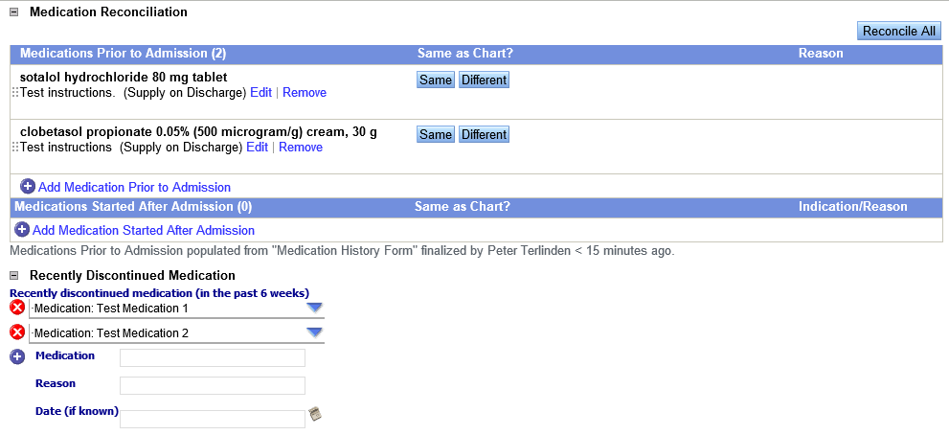
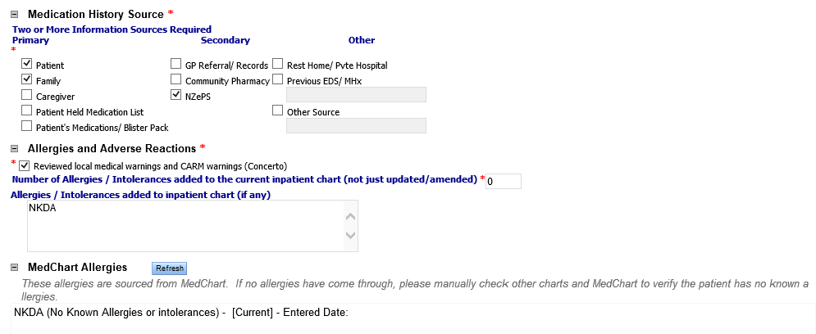
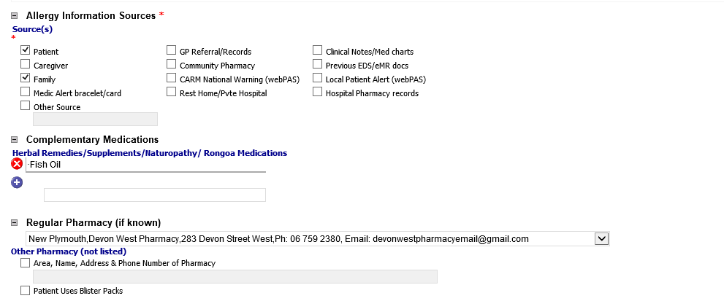
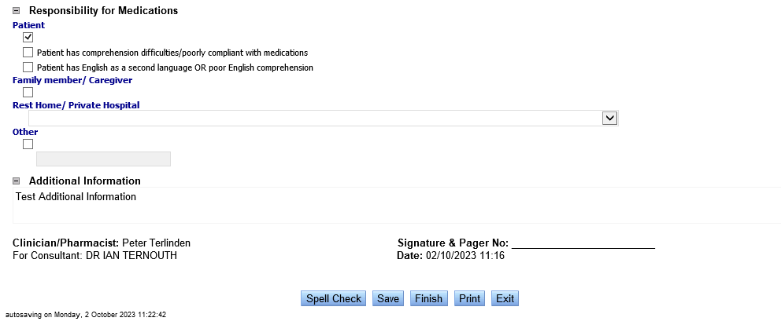

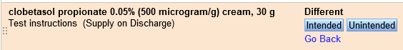
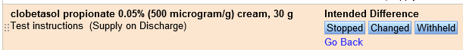
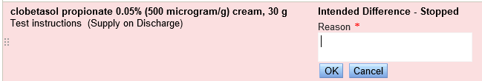

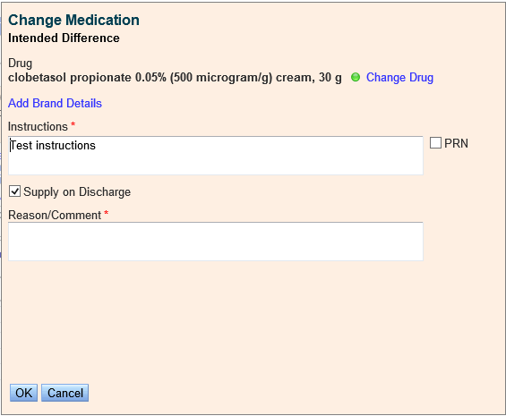
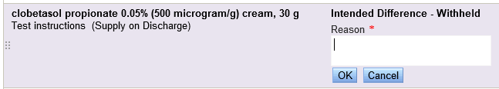

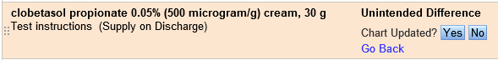
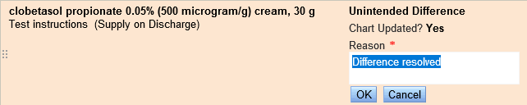
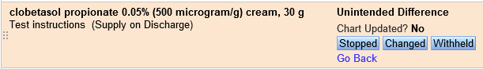
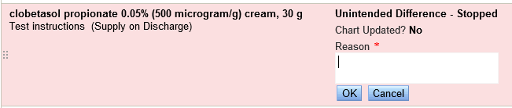
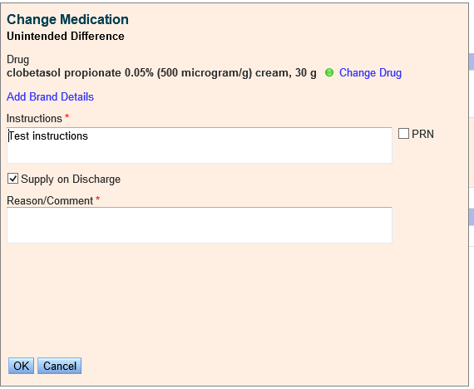
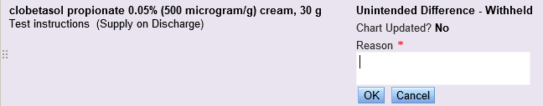
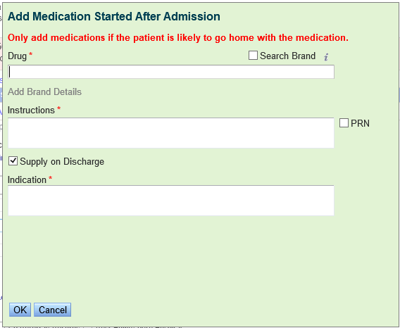

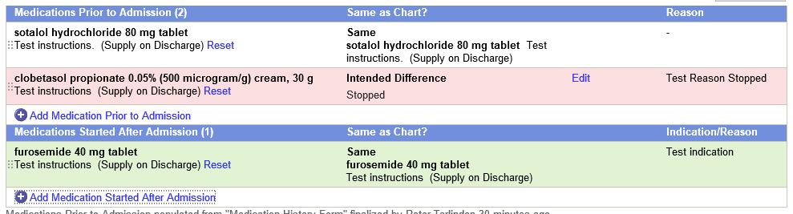

Finalised form:
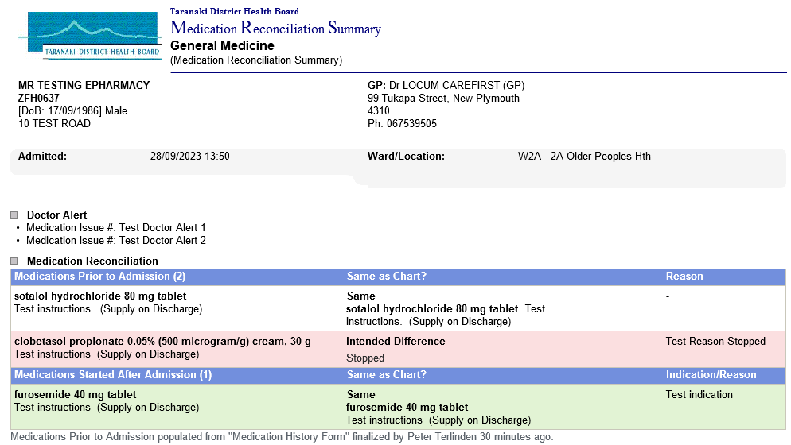
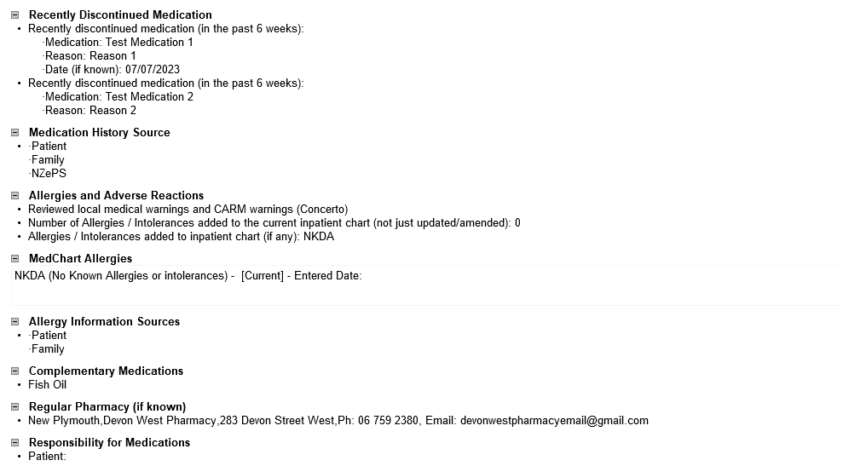
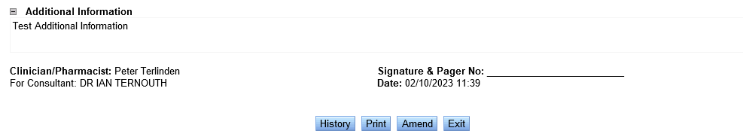

Process Flow
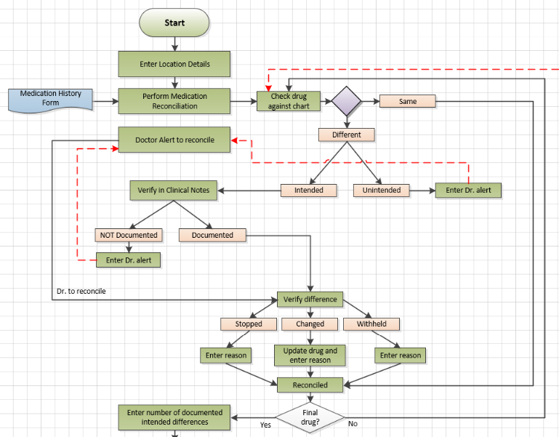

Taranaki Discharge Summary Form

Remarks
- Option to enter diagnoses.
- Separate option for Atrial Fibrillation
- Past Medical History populated from previous discharge summary.
- Data transferred from Medication Reconciliation Form:
  - Regular or other pharmacy
  - Medication Details
- MedChart allergies imported.
- Option to Continue, Change or Stop medication on Medication Details List.
- Option to select and enter Procedures.
- Option to enter appointments.
- Q: Are Appointment integrated with WebPAS? What is the process here? How to check availability?
- Q: Where are the Relevant Results coming from?

Draft Form
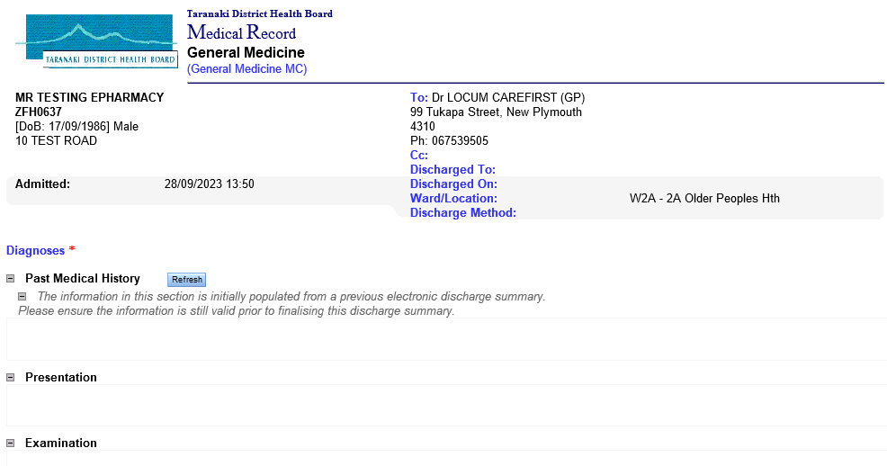
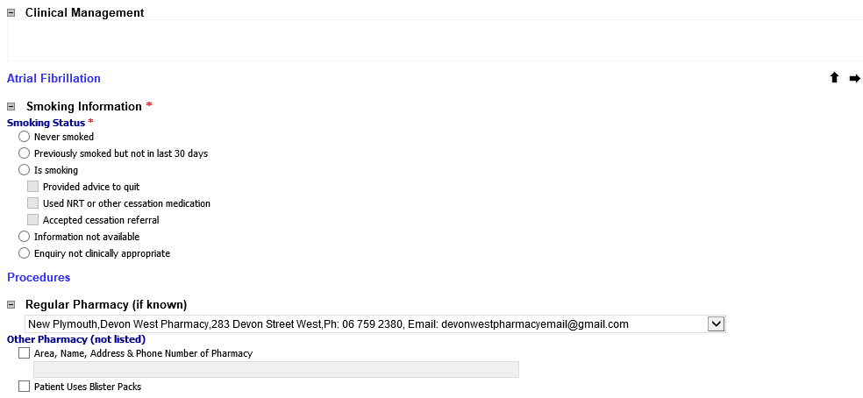
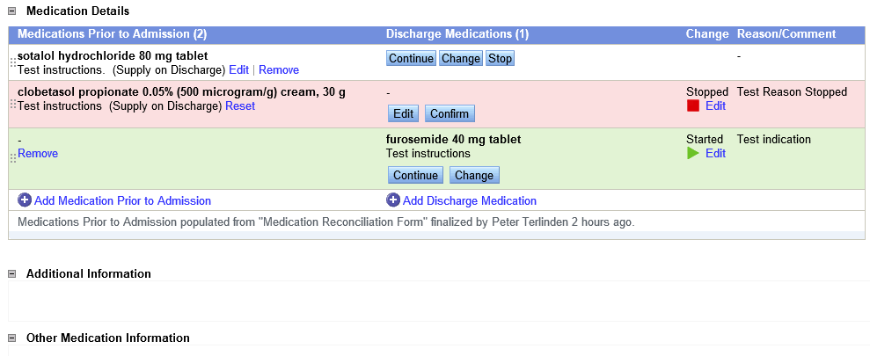
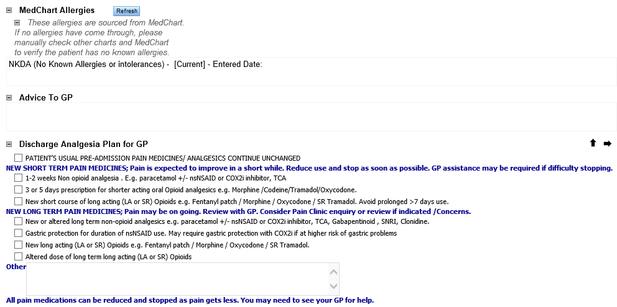
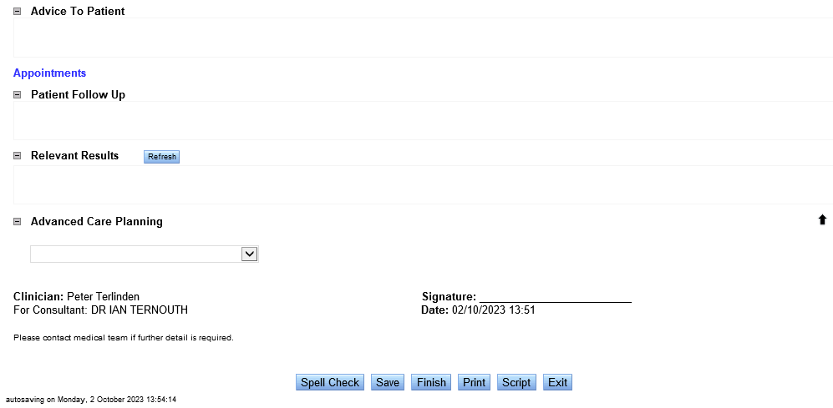

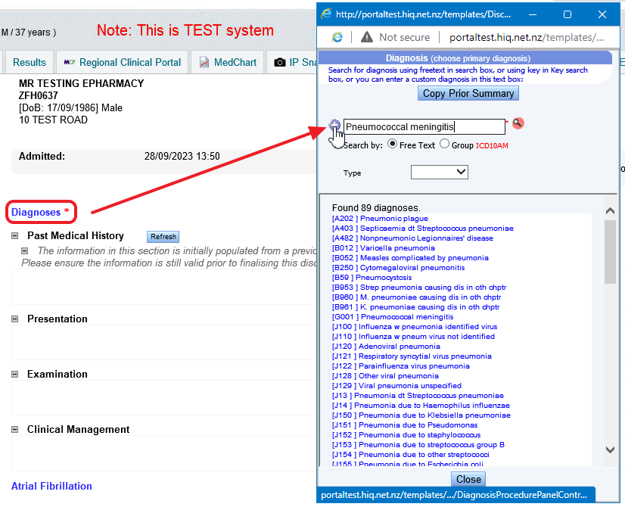

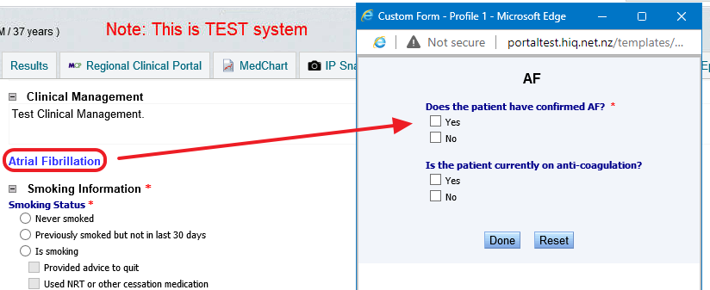

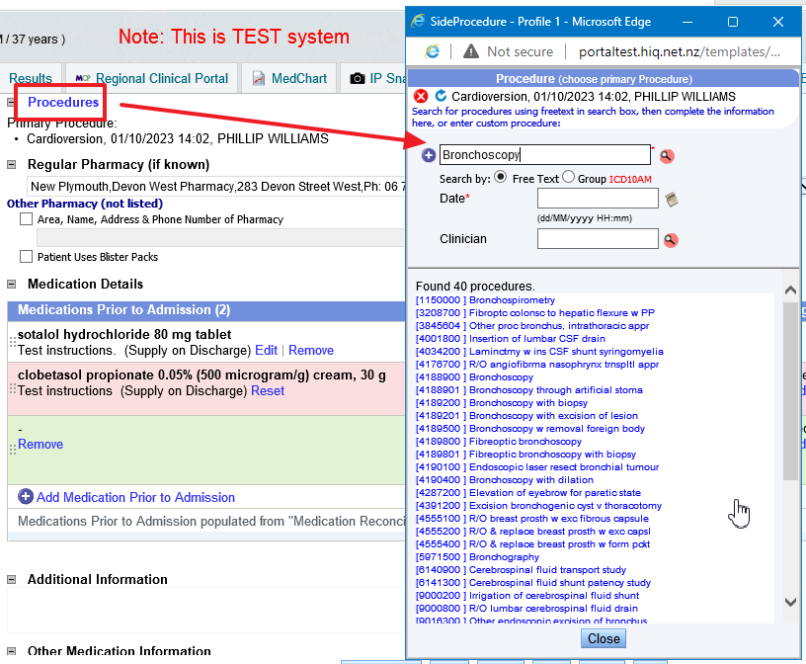

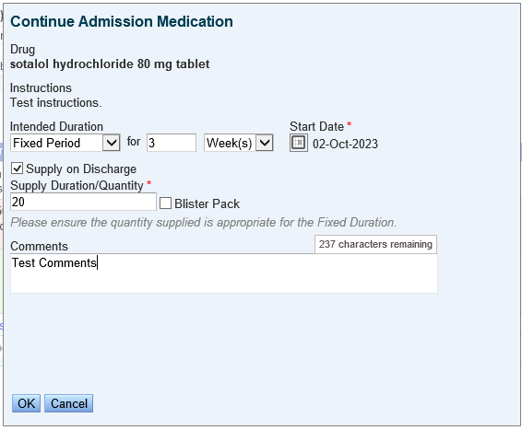
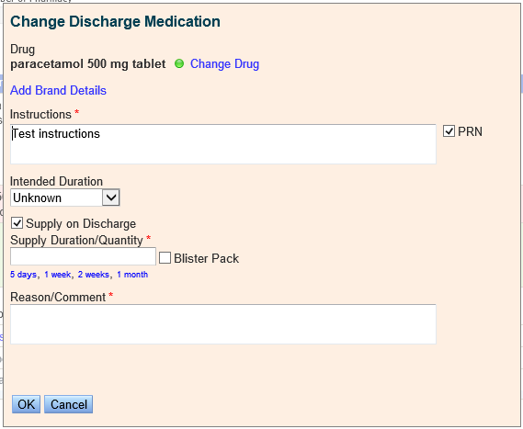
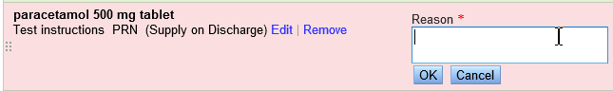
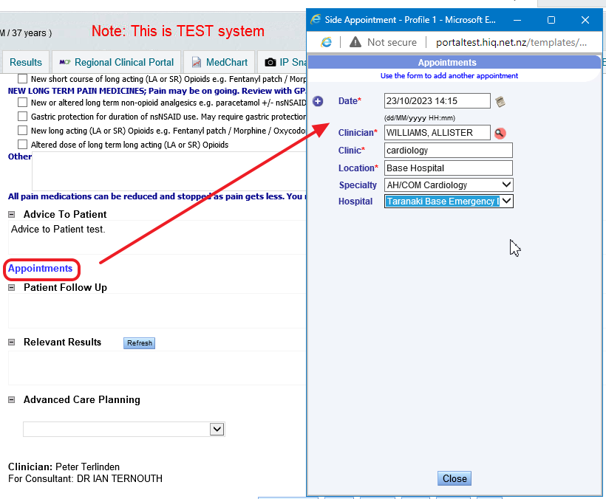

Finalised Form
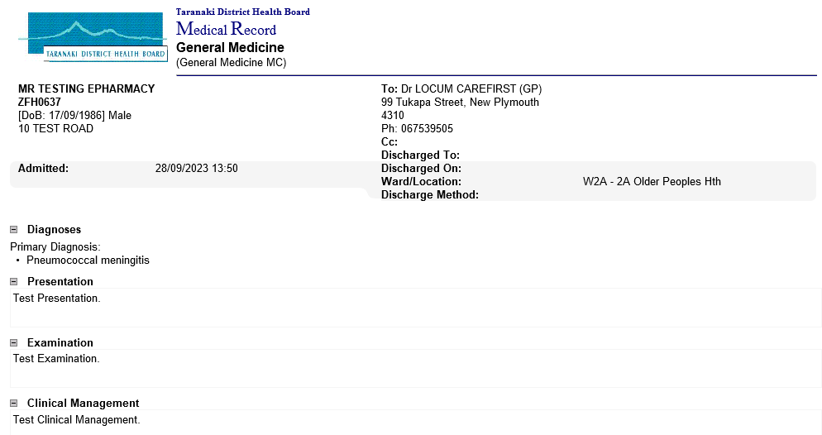
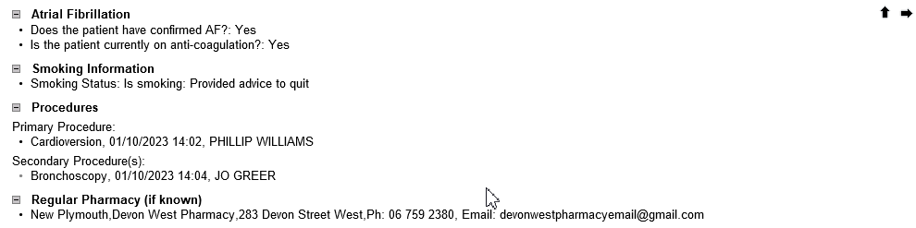
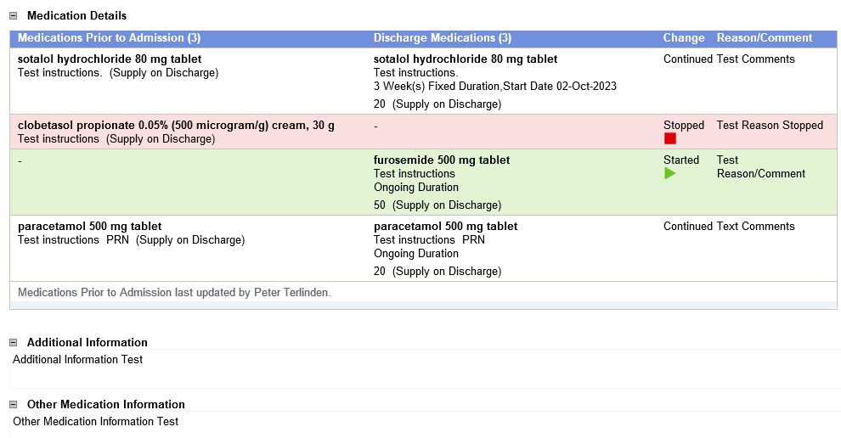
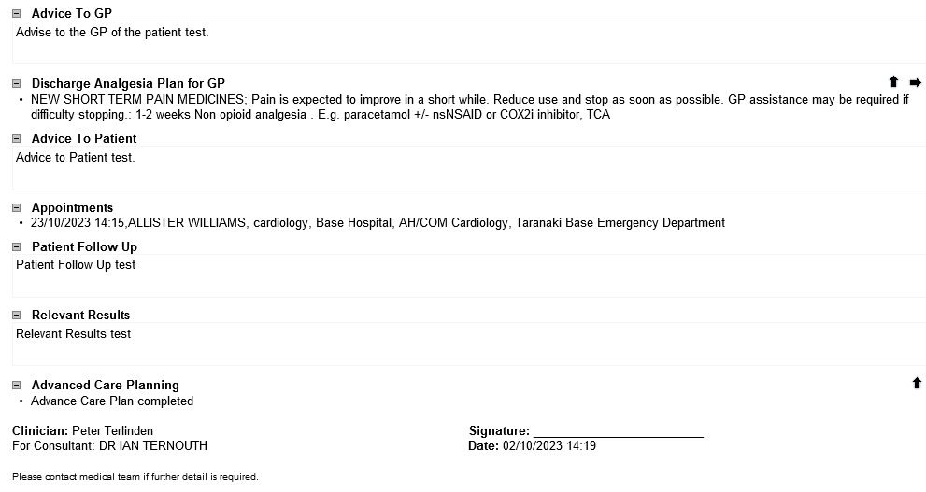

Process Flow
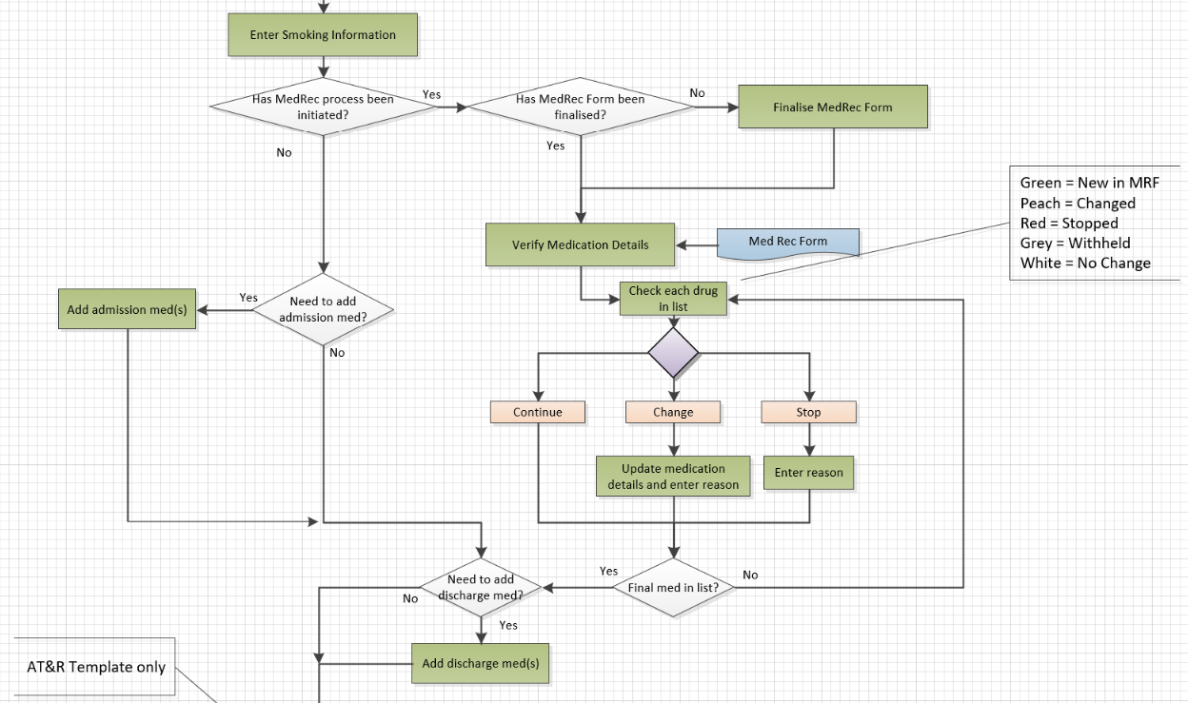

Patient Medication Card

Remarks

