Digital Rights And Social Licence Associated With Use Of New And Emerging Technologies Within New Zealand Central Government Agencies.

30 August 2019

A report prepared for the Digital Rights team in the Department of Internal Affairs

Author: Robert Hickson, Day One Futures
robert@dayonefutures.nz; www.dayonefutures.nz

Summary

A review of the current and near term uses of emerging and new technologies by selected central government agencies was undertaken to provide an indication of the technology landscape within government. A variety of new and emerging technologies are being used, such as forms of artificial intelligence, augmented or virtual reality, but these are not in widespread use. Cloud computing is the most commonly used technology, and agencies are still improving their analytics and cloud computing capabilities. There is limited information on what new technologies, or additional types of applications, will be adopted by agencies in the short term. A variety of factors, particularly organisational culture and capability, appear to be key barriers to adoption.

Human rights and social licence factors associated with technology adoption were also investigated. There is no common framework that agencies use when considering adopting new technologies. A review of the literature informed the development of a framework that can be used to help agencies, and the government as a whole, consider the ethics, trust, acceptability and accessibility issues associated with specific technologies and their applications. This V+FACETS framework covers values, fairness, accountability, credibility, engagement, transparency and security (including privacy) factors.

Section 1. Introduction

Purpose of this report

The benefits and potential harms of new technologies, particularly digital technologies, are widely discussed in society today. Both the private and public sectors are considering how use of new technologies and personal data can improve their operations, minimize harms, and benefit their customers, clients, or citizens.

This report surveys the current use of emerging technologies in central government agencies, and the anticipated adoption of such technologies in the short term (over the next five years). It then looks at the rights and “social licence” issues associated with their use. A framework is presented that could be used to support the acceptable and trusted use of new technologies in the public service.

Connections to other work in the Government Chief Digital Office

This work intersects with several other work streams within the GCDO and the Service Innovation Lab:

- Digital Identity – designing a trust framework for shared digital identity
- Digital Inclusion – ensuring that all New Zealanders can access digital services if they choose.
- Service Innovation Lab – Emerging technology trends and applications
- Futures team– technological and other developments affecting government

The common links between Digital Identity, Digital Inclusion and Digital Rights are accessibility of the technologies and trust, as illustrated in Figure 1.

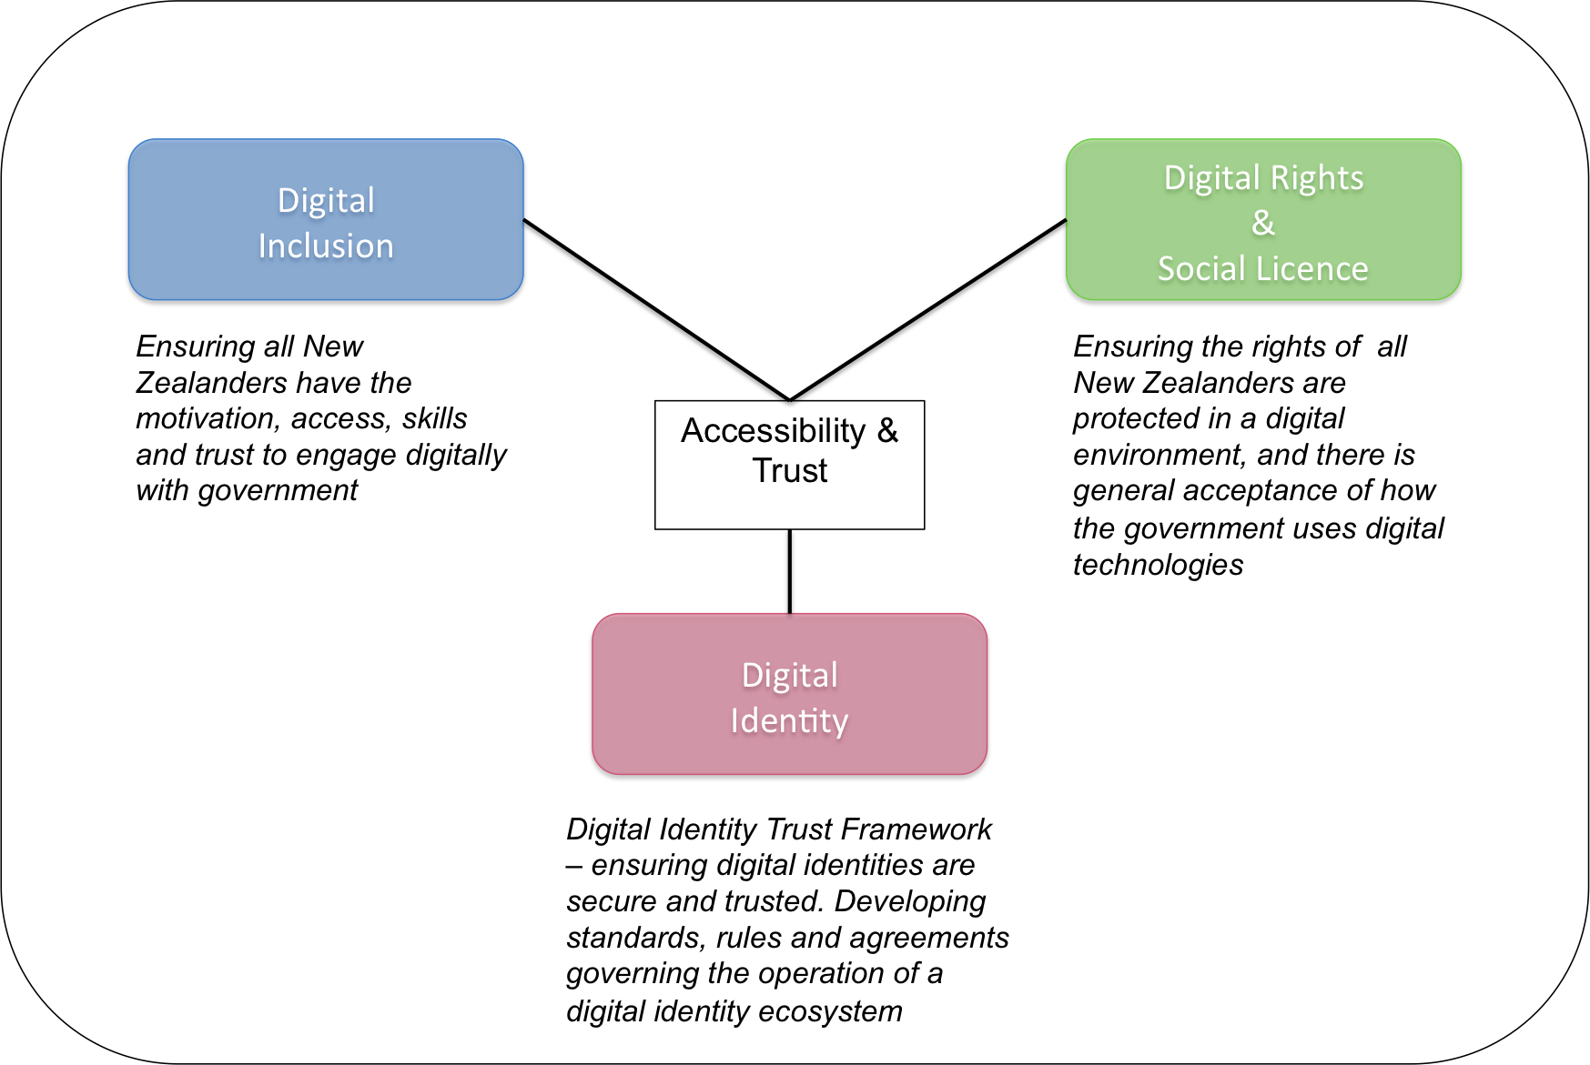

Figure 1. Accessibility and trust link the different DIA digital work programmes.

The Digital Inclusion work focuses on what the public requires to be able to access digital services. Digital Identity is about defining the needs of organisations (in both the public and private sectors) to create or use secure digital identities. Digital Rights identifies what is required of government agencies to ensure that their use of data and digital technologies is seen as trustworthy, acceptable and accessible, and so informs the other work programmes.

Process to develop this report

This work has been informed by a Service Innovation Lab-facilitated workshop with a range of central government agencies, and additional interviews with other agencies or individuals. (See Annex 1 for agencies involved). The workshop and interviews focused on current use of digital technologies, and anticipated near term uses, along with how ethical and trust issues are currently being addressed. A literature review was also undertaken to assess critical factors associated with social licence and the emerging ethical issues associated with new digital technologies.

Caveat

The uses of newer digital technologies by government presented in this report should be considered illustrative rather than comprehensive. Not all agencies participated, and some participants may not be aware of all the emerging technologies used, and how they are used, by their agency.

Section 2. “Emerging Technologies”

What are “emerging technologies”?

“Emerging technologies” is an imprecise term, but is commonly used for a range of digital and other technologies that are currently maturing or expected to be available over the next five to ten years. Examples are shown in Table 1.

Recent reports on the use of new technologies by governments, or their implications, are listed in Annex 2). In the context of this report the focus is on digital technologies rather than bio- and nanotechnologies, since the former is the focus for GCDO.

Not included in this list is what is considered “traditional” data analytics - the science of analysing raw data in order to make conclusions about that information – since that is a methodology rather than a technology. Analytics underpins all of the emerging digital technologies. Current uses of analytics (which is examined later in this report) will evolve to make greater use of data collected and generated by the emerging technologies.

Table 1. Examples of emerging technologies

Technology classes | Description | Use examples
Cloud computing | Storage and computational services accessed via the internet | Amazon web services, Microsoft Azure platform
Artificial intelligence | A suite of analytical methodologies that incorporate learning. Examples include machine learning, deep learning, neural nets, natural language processing, and machine vision | Chat bots (conversational interfaces); pre-approving benefits when specific conditions met; matching identities
Spatial computing  (also known as extended or mixed reality) | The interaction of superimposed data, graphics, audio and other sensory enhancements over a real-world environment that is displayed in real time (Augmented reality);  Creation of a virtual world or environment (virtual reality) | Head-up displays for emergency services; Training and teaching tools (eg, training surgeons on surgical techniques); “digital twins” to design, &/or maintain structures and systems (eg, a digital model of the city of Singapore)
Internet of Things | The interconnection via the Internet of devices embedded in everyday objects, enabling them to send and receive data. | “Smart” lighting, thermostats, & security cameras; remote structural monitoring of bridges
Wearable technologies | Sensors worn by people (or animals) to monitor and measure specific conditions or factors | Smart watch to monitor health parameters and environmental conditions; Compression shirt to measure physiological parameters during sport.
Biometrics | Measurement of biological features (fingerprints, iris, voice & gait recognition) for the purposes of individual identification | IRD’s Voice ID; iris scanning at immigration
Robotics | Automated machines that perform specified tasks | Surgical robots; robotic concierge; mobile robots for security and search and rescue operations
Autonomous vehicles/systems | A class of robotics. Self-driving/flying vehicles | Self-flying drones and self-driving cars
Blockchain/ distributed ledger systems | A list of records, called blocks, which are resistant to modification. Linked using cryptography, time-stamped and record transactions. | Bitcoin and other virtual currencies; blockchain application to show integrity of Dutch supermarket’s orange juice supply chain; “smart” contracts for insurance agreements
Additive manufacturing | 3D printing | Printing patient-specific prosthetics
Neurological technologies | Brain-computer interfaces | Disabled people able to interact with electronic devices using brain signals
Quantum computing | Computation based on quantum theory rather than traditional binary computing | Still under development. Much more powerful computational systems.
Biotechnologies | Gene sequencing, genetic modification, gene therapy, synthetic biology | Genetically modified organisms for health, agricultural or industrial uses; gene editing for medical therapy; gene drives for pest control
Nanotechnologies | Technologies derived from manipulating matter at the very small scale | Coatings that repel water and dirt to reduce infrastructure maintenance; microscopic medical devices and environmental sensors
Other | Miscellaneous technologies. Such as geographic information systems (GIS);  microsatellites | Layering of information to study urban growth; monitoring of environmental conditions or human activities

Organisations adopt technologies at different rates, and for different purposes. Consequently, for those that are “early adopters” they may not consider some of the technologies as “emerging” any more, while later adopters still consider them novel.

Drivers for technology adoption

Drivers for adoption of new technologies include:

- Technological developments, making digital tools more cost effective, relevant, and/or accessible
- Increasing amount of data being collected
- Improving efficiency of government activities
- Expectations from customers and citizens – not just in technology services, but in how government works with communities to address issues
- Changing nature of government-citizen relationships – particularly more collaborative decision-making and delivery
- Increasing complexity, and global nature, of many governance challenges

Several factors influence decisions to invest in new technologies or applications. At the highest levels these relate to organisational need, technological maturity, organisation culture, implementation costs, organisational capabilities, and societal or customer acceptance (Capita 2019, DLA Piper 2018, McKinsey 2018, Spiceworks 2018).

Based on the workshop and interviews with agencies, two main external drivers influencing adoption of new technologies were identified. These are expectations from the public and businesses, and the disruption to traditional practices and services from technological innovations (Table 2).

Table 2. External factors influencing technology adoption

Driver | Rationale
Public/customer expectations | The public often assume government is keeping pace with private sector adoption & applications
Public/customer expectations | The public often assume/expect that agencies are well connected/integrated and able to access information given to one part of the system
Technological change | Disintermediation of processes and services through technology “disruption” of traditional service models
Technological change | Disruption to existing systems (eg, the potential for electric vehicles to reduce revenue from petrol tax)

Factors within agencies that are important influences of technology adoption include cost and resource factors, a clearly articulated narrative or vision, and ability to address particular needs (Table 3).

Table 3. Internal factors influencing technology adoption

Driver | Rationale
Resource availability | Availability of resources to invest in new technologies
Resource availability | Lack of legacy systems can enable more rapid adoption
Business case | Cost effectiveness of new technologies/applications
Business case | Nature of the problem needing to be addressed
Communication | Effective communication of the “technology story” can help agencies adopt new technologies
Resilience | New technology helps mitigate risks of disruption to services

External factors that can inhibit adoption of new technologies or applications often relate to lack of trust and knowledge, and complexities of obtaining permission to use sensitive or personal data (Table 4). For agencies that work with third parties to deliver services, the latter’s lack of capabilities or technological readiness can also be a barrier.

Table 4. External barriers to adopting new technologies

Barrier | Rationale
Lack of trust | In institutions in how information is used
Lack of trust | In the tools and people using them. Eg, assuming that no “humans in the loop” (such as only a digital assistant available)
Lack of trust | Ethical basis of use
Knowledge | Limited understanding of the processes &/or data used by agencies
Knowledge | Explainability of what information is required for and why
Permission | Individual and collective attitudes to rights and data sovereignty
Permission | Different rights and security for data
Permission | Having/obtaining permissions to share information
Capabilities | Partner organisations’ abilities to use new technologies

In both the public and private sectors awareness of opportunities provided by new technologies doesn’t often lead to rapid widespread adoption. The culture of the organisation is a key barrier to change. International surveys identify lack of vision and strategy, management pushback, and risk aversion as major inhibitors (Capita 2016).

This was apparent in responses from New Zealand agencies. Notably, internal barriers were the most numerous factors identified during the workshop. Many of the internal barriers identified by agencies relate to an absence or limitation in capabilities. In addition to cultural barriers, information and knowledge gaps, resources and legal requirements can also be important barriers (Table 5).

Table 5. Internal barriers to adopting new technologies

Barrier (Internal) | Rationale
Culture | Lack of understanding/technical skill of new technology/application/system
Culture | Weak connections between service delivery and policy teams
Culture | Lack of recognition of effort required to deliver change
Culture | Getting leadership “across the line” – ability to demonstrate small wins
Culture | Lack of an influential internal “champion” to promote new approaches
Culture | Not open to new ways of working. Eg, old governance and approval processes too slow
Culture | Risk appetite – being too risk averse
Culture | Lack of vision
Knowledge | Lack of good independent analysis and advice on what is likely to be suitable and appropriate
Knowledge | Lack of timely guidance on procurement and security processes
Knowledge | Uncertainty of what data is required for specific needs
Knowledge | Uncertainty over what data is able to be retained or discarded
Funding | Money and funding models may not be suitable/sufficient to support change
Legacy systems | Other technology priorities take precedent (eg supporting/upgrading core systems)
Legacy systems | Difficulty/inability to change or evolve existing systems
Data | Amount of data required
Data | Restrictions (or lack of permissions) on how & who can access data and connect it to other data sets
Business case | No compelling use case for the technology
Legislation | Laws limiting access or use (eg legislative requirements for some types of data to be retained in NZ

The UK’s National Audit Office (2019) recently noted that data is often not seen as a priority by government agencies. There can be too little attention given to data quality, and there can be a culture of tolerating or working around poor quality data.

The World Economic Forum identifies five challenges for governments wanting to adopt artificial intelligence: ineffective use of data, lack of data management and AI skills, the fragmented nature of the AI market, the conservative practices and processes of the public sector, the treating of algorithms as intellectual property, making it difficult for agencies to modify products from vendors (WEF 2019).

Use of new technologies by NZ Government agencies

The workshop and interviews provided examples of how newer digital technologies are being used, and what some short-term future uses are likely to be. The Algorithm Assessment report was also used to provide additional application cases. The results are indicative only, since a comprehensive survey was not undertaken. Many central government agencies have not been surveyed, and those involved in the workshop and interviews may not be aware of all uses of new technologies within their agencies.

Data from the Ministry of Health include some technologies used by District Health Boards rather than the Ministry itself. This information will also underestimate the range of technologies and how they are applied in the medical sector. However, the information obtained from the Ministry of Health has been kept to illustrate some of the applications beyond central agencies.

The information in this section is presented in three ways. Firstly, heat maps illustrate the number of agencies using particular technologies and the types of uses involved. The types of use categories (Table 6) were developed based on a range of reports, and provide a means to better characterize how technologies are used, rather than just noting what technologies are used. These categories are somewhat simplified, and a particular use can fall into more than one category. For this analysis uses have only been assigned to one category.

Secondly, agency adoption of the technologies is illustrated in simple network maps to indicate distribution of technology use. Finally, examples of particular use cases are provided in Annex 3.

Table 6. Categories of technology use

Utility Function | Purpose | Description
Administrative | Transaction | Undertake financial transactions
Administrative | Manage | Manage other administrative functions. Such as data management, information processing.
Administrative | Security | Provide security for information systems
Analytical | Generate knowledge | Creation of knowledge from data
Inform | Educate | Use in teaching or training
Inform | Recommend | Provide a recommendation, such as for additional products or services
Inform | Communicate | Automated written or verbal communication with staff, customers or clients
Identify | Match | Match information records. For example identity matching
Identify | Diagnose | Identify a particular condition. For example, medical condition or behavioural state.
Predict | Prediction | Predict consequence or course of action
Decision | Decision-support | Providing information that supports a decision, or system that makes its own decision. For example, risk assessments, payment approvals, or transport route determinations
Decision | Behavioural | Uses that are intend to influence in behavioural responses. For example, reducing anxiety
Physical | Physical task | Machines able to undertake physical tasks

Technology use heat maps

For the agencies surveyed most of their current activity centres on data analytics (to varying degrees of sophistication). As noted earlier, this isn’t a technology but is an important aspect of digital technologies so is included in the first heat map to provide context. Not all of the agencies indicated that they are using analytics, although it seems likely that they all are. Cloud computing is the most commonly used “new” digital technology. A few agencies are currently testing or using artificial intelligence methods for a small number of applications.

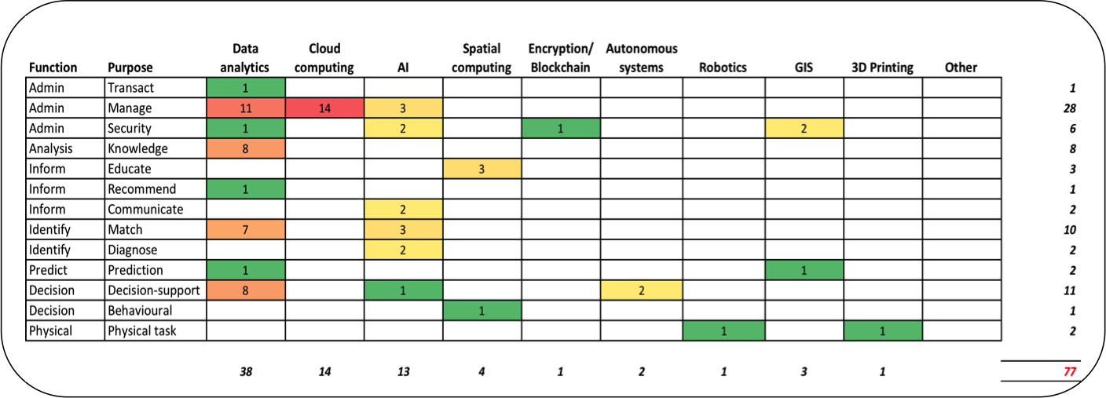

Figure 2. Indicative current use of digital technologies by 18 government agencies. Numbers relate to number of agencies using the technologies for different purposes.

There is less clarity from agencies about future uses of technologies (12 agencies identified future technology uses), even over the short term, suggesting a cautious approach to adoption. Based on the interviews with agencies, this cautious adoption is a consequence a range of factors (see Table 5). In some cases this can be attributed to lack of awareness at senior levels for the benefits a new technology could bring, in other cases there can be data and capability gaps, while for some agencies there is as yet no compelling use case for a particular new technology.

There will be continuing utilisation of cloud computing services, as well as an increase in use of artificial intelligence methods (particularly for matching and communication purposes), robotic and autonomous systems (Figure 3). Additional technologies are likely to also be used, such as microsatellites for environmental monitoring.

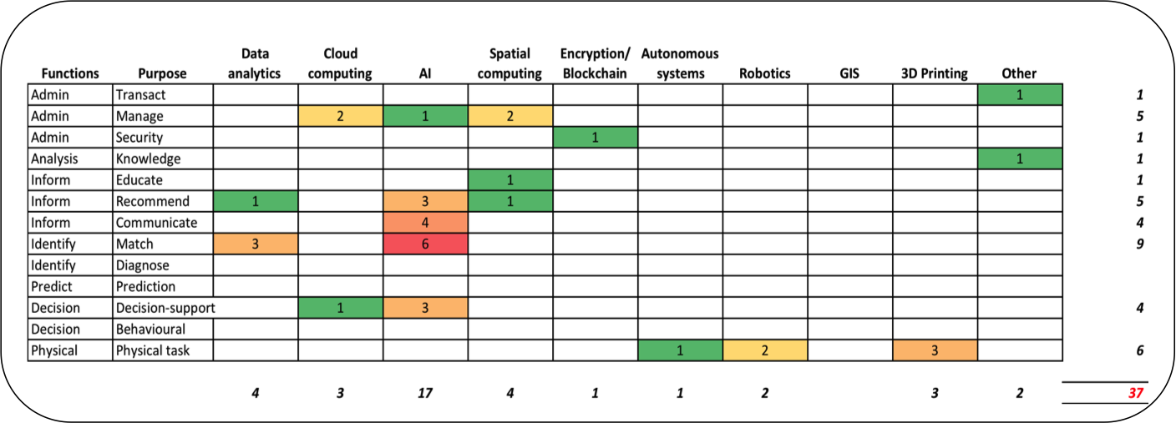

Figure 3. Indicative future uses of digital technologies identified by 12 government agencies. Numbers relate to number of agencies indicate using the technologies for different purposes.

Network maps of agency use of emerging technologies

To illustrate technology use network maps were created. These show the technologies individual agencies are using (or anticipate adopting in the future), and they types of purposes they are being used for. In figure 4 the types of uses data analytics is currently applied to are illustrated. The size of circles in these maps is scaled to the relative number of connections each element has. Managing, matching and knowledge generation are the predominant types of uses, with seven of the 16 agencies indicating that they are using analytics for at least three types of purposes.

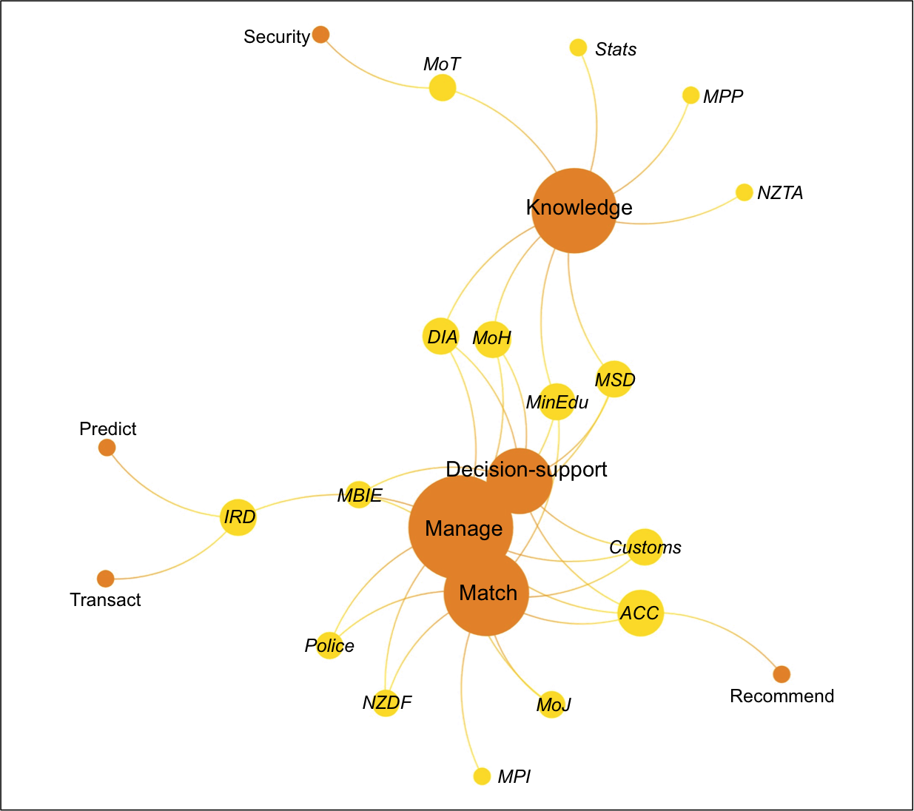
Figure 4. Network map of 16 New Zealand government agencies and how they are currently using data analytics. Size of circles indicates relative number of connections. (Agencies coloured yellow, type of use coloured orange)

In subsequent maps the data analytics category has been excluded to keep the focus on technologies. Figure 5 shows that most (nine) of the agencies currently use only one of the technologies – predominantly cloud computing. Another nine currently use two or three technologies.

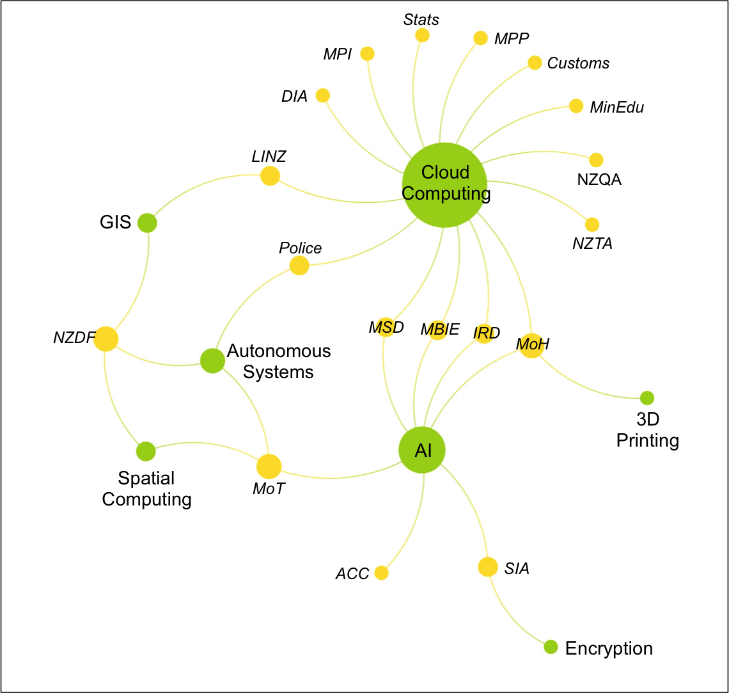
Figure 5. Network map of 18 New Zealand government agencies and the types of emerging technologies they are using currently. Size of circles indicates relative number of connections. (Agencies coloured yellow, technologies green)

The predominant purposes of using these technologies currently is to manage information, reflecting the common purpose of cloud computing. Other purposes are for matching, supporting decision-making and generating knowledge (Figure 6).

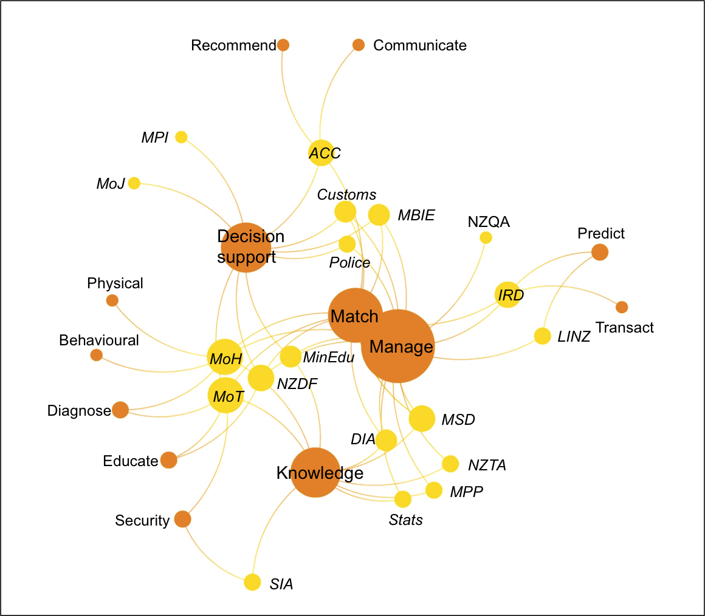
Figure 6. Network map of selected New Zealand government agencies and the current types of uses of new technologies. (Agencies coloured yellow, use orange)

Anticipated use within the next few years focuses most on use of artificial intelligence applications, (12 agencies; Figure 7). Some new technologies appear in the future list – microsatellites (for environmental sensing) and new payment systems (such as those already being provided by large technology companies – eg, Alipay from the Alibaba Group). Several agencies were not able to identify what new technologies they could use, while some indicated that they would be continuing to improve data analytic capabilities and adoption of cloud computing.

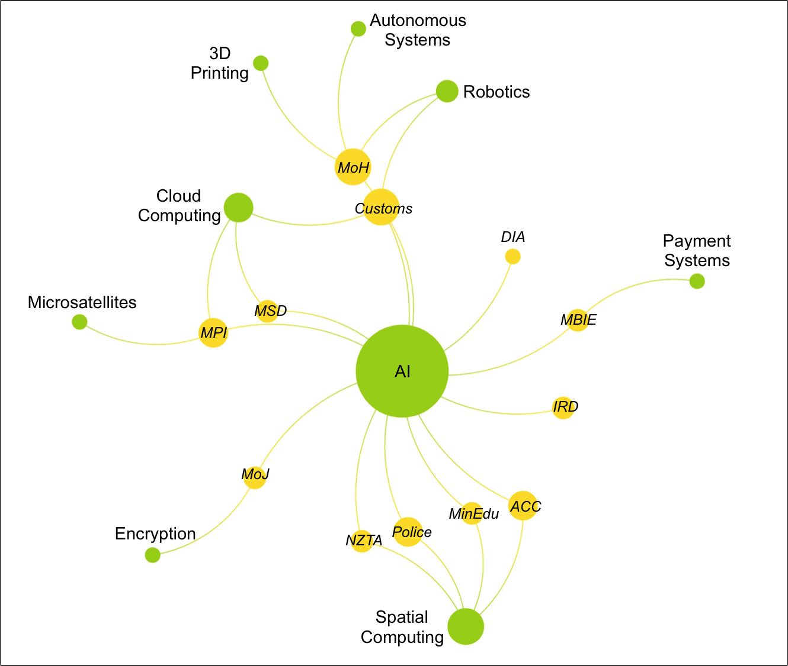
Figure 7. Network map of New Zealand government agencies and the types of new technologies they are likely to adopt in the next few years. (Agencies coloured yellow, technologies green)

International comparison

Finding equivalent information on technology use by government agencies in other countries is difficult. An exception is the UK. In 2018 they published the results of a survey of what technologies a broad range of agencies are using, and how they are using them. A network map of some of their data is shown in Figure 8. A more detailed visualisation created by the UK’s Government Digital Service is available at graphcommons.com

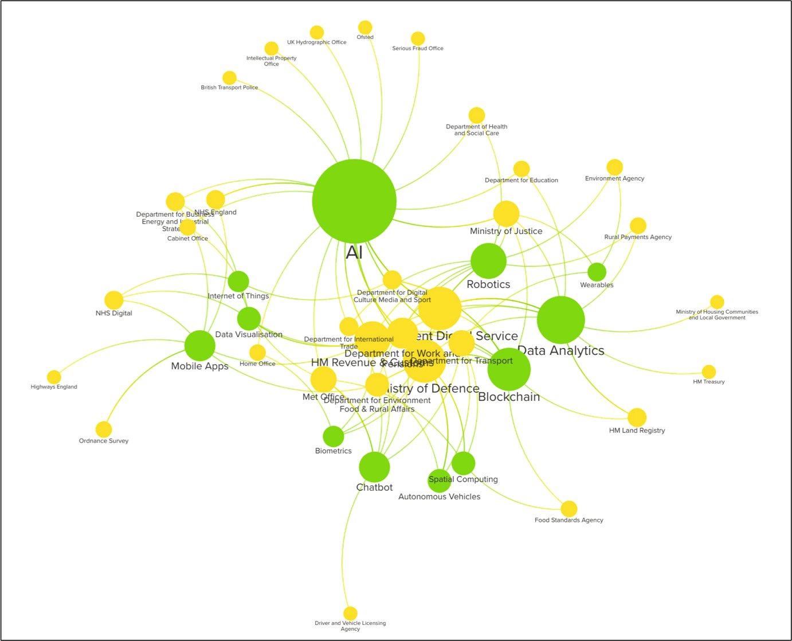
Figure 8. Use of digital technologies by UK government agencies (data from UK Government Digital Service).

Compared to New Zealand, the UK government is more advanced in the use of new technologies, with substantial activity involving artificial intelligence methods. Examples of how they are being used (UK Government Digital Service 2018) may be useful for New Zealand agencies. Due to a lack of comparable information from other governments it is difficult to determine whether New Zealand government agencies are relatively slow adopters of digital technologies, or similar to countries other than the UK.

Summary of Section 2

New Zealand government agencies appear cautious in adopting new technologies. Many are still focused on improving existing analytical capabilities for data they already collect, while the awareness of the benefits and risks of newer technologies seem relatively immature in some agencies.

There is a move toward greater use of cloud-based computing services, and this is informed by analysis of costs and other benefits and risks. Based on comments at the workshop and from interviews, cultural factors (such as lack of awareness and limited forward thinking) and under developed analytical capabilities and capacity within agencies seem likely to be common constraints for adopting new technologies. On the other hand, some agencies have considered new technologies and have not yet seen compelling cases for their use, so it is not always a case of agencies being uninformed or unprepared.

Section 3. Digital Rights and “Social Licence”

What are digital rights?

“Digital rights” is the concept that people should enjoy the same basic human rights when interacting digitally (with an individual or an organization) as in the off-line world. That is, they should enjoy equal freedom and dignity under the law, the protection of civil, political, and social rights, the universal recognition of personhood, and the right to free and unencumbered participation in the life of the community.

What is “social licence”?

Social licence (or “social licence to operate”) is less tangible than rights, and is often poorly or inconsistently defined. It can be applied in diverse contexts in different ways, creating confusion (Edwards et al 2019). Generally social licence encompasses:

- acting within the law;
- being credible and accountable;
- acting fairly and responsibly;
- acting predictably and consistently;
- acting “ethically”;
- aligning with societal expectations; and
- building and maintaining trusted relationships with relevant stakeholders.

The Data Futures Partnership framed social licence as the acceptance by individuals for organisations to use their data, information and stories. They identified value, choice and protection as critical factors associated with trusted use of personal data and information.

Statistics NZ’s defined social licence as “the permission it has to make decisions about management and use of the public’s data without sanction.” Their social licence framework has four “pillars” of expectations:

- Purpose & benefits: personal information is to be used for purposes that are positive and beneficial to society;
- Privacy: Stats NZ understands the risk to us of unsafe data use and is committed to maintaining our privacy, and as such has put in place robust security processes to protect our personal information;
- Transparency & accountability: Stats NZ’s process for stewarding personal information is transparent and accountable; and
- Engagement: Stats NZ will actively engage with us and take into account our views on how our personal information is managed and used

The Social Investment Agency’s consultations with New Zealanders (SIA 2018) noted the need for cultural competence (an awareness and understanding of cultural diversity, and the ability to function effectively and respectfully when working with people from different cultural backgrounds) when agencies engaged with different groups and communities, and for information exchanges to be two-way, rather than simply from the public to the government.

Social licence is essentially about giving permission to an organization (or group of organisations) that is deemed trustworthy to undertake specified activities that have risks. Originally it was conceived of as a counterpart to a legal licence to undertake n proscribed activity. Trustworthiness is the ability to create trust, with trustworthiness being the result of legitimacy, credibility, integrity, reliability, and a range of other factors. Trust comes from an organisation being deemed to be trustworthy (Edwards et al. 2019).

An organization therefore needs to focus first on being seen as trustworthy, independent of specific initiatives. A challenge for government agencies is that while an individual agency works to be viewed as trustworthy the activities of another agency could unintentionally undermine that because the public usually views them all as “the government.” Consequently, actions to build and maintain trustworthiness across government rather than just within individual agencies are necessary. The State Services Code of Conduct provides the basis for being regarded as trustworthy.

Where social licence is being used

Originally social licence related to mining companies having the permission from local communities to operate near them. Subsequently it spread into other areas associated with use of natural resources, such as energy, farming, forestry and fisheries.

In New Zealand social licence has previously influenced government policy on energy projects, on nuclear power, genetic modification, and the use of human assisted reproduction. It is also a growing factor in discussions about methods of pest control.

Social licence has started to influence companies that work in manufacturing, retail, and other areas. The issues these focus on are whether they have fair and safe labour practices, support other social justice initiatives, and/or minimize environmental impacts.

Discussion about social licence within government is, according to Gehman et al. (2017), a reflection of a shift towards “networked governance.” A move away from centralised control and decision-making means that organisations have to increasingly show how they are giving regard to the views of other affected parties.

Social licence, framed as an ethical issue, is also a growing focus of discussion for how well organisations (in the private and public sectors) protect the privacy of those whose personal information they collect. This is reflected in the 2017 report from the Data Futures Partnership “A path to social licence: guidelines for trusted data use” and their “data dial.”

Critiques of social licence

The varied contexts and ways in which social licence has been used can create confusion about what it is (Gehman et al. 2017, Jenkins 2018). The term “licence” may give the impression that it is something that is well defined, when in fact it is “fuzzy edged” (Jenkins 2018). Its vagueness can make it “… essentially a metaphorical and rhetorical notion, bearing little resemblance to a license in the legal sense” (Parsons and Moffat 2014).

The concept of social licence can create the impression of a simple test or checklist, which if completed to certain standards permits activities to proceed. The concept implies a binary state – you either have a licence or you don’t. However, there isn’t usually clarity about what needs to be done to obtain and maintain “social licence”, nor what constitutes a revoking of a “social licence.”

Some consider that attempting to achieve a social licence has the potential to give too much influence to small vocal groups within communities. Another reservation is that industry or governments can use the term without having meaningful open discussions with other stakeholders (Gehman et al. 2017).

Te Mana Raraunga, the Māori Data Sovereignty Network, has raised concerns about a focus on “social licence” with respect to partnership agreements under the Treaty of Waitangi. They suggest that “social licence”, which can imply a focus on individuals giving (or not) approval rather than communities, does not reflect Māori cultural protocols and practices. A more appropriate concept for Crown-Iwi partnerships, in their view, is “cultural licence”, based on trust that Māori Treaty partners have with the intended uses.

Social licence is often depicted as having different levels; from acceptance, through approval, and up to co-ownership. However, Jenkins (2018) notes that judgement by communities and individuals is usually multi-dimensional rather than linear. That is they will decide if activities are legitimate based on a blend of their own assessments of legality (“Are they following the law?”), cognitive (“Do I understand what they are doing, and why?”), pragmatic (“What benefit do I get?”) and moral (“Are they doing the ‘right’ thing, in the ‘right’ ways?”).

What does a digital “social licence” look like?

Discussions with agencies did not provide much detail on the frameworks they use for assessing ethical and public acceptability of new technologies. MSD’s PHRaE framework informs decisions they make about initiatives. Other agencies can have ethics or governance groups, but there is at the moment little consistency in approaches. All agencies interviewed were aware of the ethical, fairness, security and other issues associated with use of some of the emerging technologies.

Given the confusion that the term “social licence” can cause it is preferable to explicitly define what this encompasses, or to focus on the elements that contribute to trustworthiness, acceptability, and other factors. “Social licence” is ultimately about building constructive relationships with “stakeholders”, based on transparency, honesty, mutual respect and trust.

Regardless of the framework used, essential questions when considering “social licence” for agencies are:

- Does use of the technologies decrease or increase the self-determination and dignity of the people they affect?
- If the application was aimed at a different group, would it be acceptable?

Essential questions for communities are:

- How do we benefit from this?
- Is this fair?
- Does this reflect our values and aspirations?
- Is the government agency listening to us?
- Are they responsive to our needs and issues?
- Can we believe them?
- Can we trust them?

Rather than consider the process as about obtaining a “licence”, a more constructive approach, suggested by Jenkins (2018), is to consider what a specific use or application aims to achieve in terms of outcomes, and the level of societal support and engagement that would be expected; ranging from passive involvement (informed acquiescence) up to participatory co-design, and perhaps co-ownership.

The standards for integrity and conduct for the State Services provide a critical foundation for all activities that central government agencies undertake.

The Data Futures Partnership identified that the key factors associated with ensuring that the use of personal data has a “social licence” are value, choice and protection. Stats NZ pillars are benefit, privacy, transparency and engagement. These apply to the use of digital technologies too, but there are additional factors to consider. These cover the methodology and process aspects of the technology, including the potential for bias, transparency of processes, accuracy and reliability, the roles people play, and accountability.

Ethical guidelines to inform the use of new technologies, particularly applications involving forms of artificial intelligence, are proliferating. However, developing ethical applications is a contributory factor toward “social licence”, not social licence by itself.

Much of the discussion on the ethics of emerging technologies has focused on algorithms and artificial intelligence. However, many of the issues are relevant to other technologies as well.

Reports on ethical development and use of technologies (from governments, NGOs, and the private sector) cover many of the same themes, although they can give different emphases to them. The Principled Artificial Intelligence project being run by the Berkman Klein Center at Harvard University is mapping the human rights and ethical principles and guidelines used in reports about AI.

The common themes they identify cover:

- Human rights
- Protection of human values
- Professional responsibility
- Human control of technology
- Fairness and non-discrimination
- Transparency and explainability
- Safety and security
- Accountability
- Privacy

A detailed assessment from the Berkman Klein Center will be published later this year.

A report from The Alan Turing Institute sets out three ethical building blocks (Values, Principles and Governance arrangements) that AI projects should consider. The Turing report advocates for connecting values with principles that are actionable, and linked to governance arrangements that focus on processes, not just responsibilities.

- Values framework – identifying the ethical values that support, underwrite, and motivate use of the application. It should consider how the initiative will:

  - Respect the dignity of those potentially affected;
  - Connect with those involved sincerely, openly and inclusively;
  - Care for the wellbeing of all involved; and
  - Protect social values, justice and the public interest.

- Actionable principles to inform design and use. The principles involve:

  - Fairness – in data used, design, implementation, and outcomes
  - Accountability – in terms of explainability of methods and results, and auditability of processes
  - Sustainability – consideration of the impact on stakeholders that use (of AI) will have on communities, and the technical sustainability of the application (is it safe, accurate, reliable, secure, and robust?)
  - Transparency – transparency both in terms of explaining the results, as well as in justifying the design and implementation processes, and in the outcomes

- A process-based governance framework to establish transparent design and implementation processes.

The Alan Turing Institute captures many of the issues raised by the other reports. However, it goes into more depth than the other reports by discussing the need to consider principles and processes with respect to data, design, implementation and outcomes; aspects that many frameworks do not distinguish. The values and principles they identify can apply to other digital technologies as well.

Regardless of the technologies used, the critical issues will be the implications of the services, decisions or activities; the role technologies play in making or informing decisions; the accuracy, reliability and transparency of the information and methods being used; and the perceived credibility and trustworthiness of the organisation(s) involved.

Caution should be taken in assuming that because the same or similar process has been used previously (but without this particular technology) then there will be no new issues to consider. People can have different levels of acceptability about how something is done, particularly if they are less familiar with the new(er) technology or approach. For example, a semi-manual approach using a spreadsheet may be regarded differently than if a fully automated algorithm was used.

As a starting point, and as noted earlier, it can be useful to consider:

- Does use of the technologies decrease or increase the self-determination and dignity of the people they affect?
- How would they benefit from this approach?
- If the application was used on a different group, would it be acceptable?

A draft framework

To facilitate discussion of the ethical, trust and accessibility issues associated with the use of digital technologies by government agencies in New Zealand the following framework is suggested as a starting point. It builds on the Principled Artificial Intelligence project and The Alan Turing Institute’s “FAST” principles by highlighting more strongly engagement and credibility aspects derived from social licence discussions.

It is called the V+FACETS framework (Table 7), an acronym for Values, and the principles of Fairness, Accountability, Credibility, Engagement, Transparency, and Security. More details on these are included after the table, along with some critical questions for agencies to consider for each.

Table 7. A draft framework for assessing accessibility, acceptability and trust for applications involving new technologies

Values | Principles
Values | Fairness | Accountability | Credibility | Engagement | Transparency | Security
Protect: Uphold human rights | Minimising bias | Answerable | Organisational competence | Open | Purpose & uses | Privacy
Respect: Respect of autonomy | Ensuring accessibility | Auditable | Technical competence | Ongoing | Explainability | Security
Connect: Inclusive & equitable engagement, and equity of access to services | Being inclusive | Oversight | Integrity | 2 way communication | Justifiability | Robustness
Care: Focus on providing benefit to the public and improving the wellbeing of all

Values

The values expressed and demonstrated by an organization are critical for establishing trustworthiness. In the case of government agencies using digital technologies, essential values that reflect societal norms and expectations of the public service, are:

- Protect and uphold human rights in digital environments, and protect social justice and the public interest;
- Respect the autonomy of individuals and communities, and their rights to choose what data and information they share, and how they wish to engage with the government. Respect and comply with the obligations of the Crown as a Treaty of Waitangi partner;
- Connect with those involved professionally, openly and inclusively, and ensure equity of access to government services and information; and
- Care for the wellbeing of all involved through using applications of new technologies in ways that provide benefits to the public and businesses.

An issue that isn’t often noted by ethics frameworks is environmental sustainability, which can be included under the “care” component. High levels of energy consumption by server farms, some AI and blockchain applications can potentially have significant adverse environmental impacts. The energy footprints of government agencies may become a more important issue some New Zealanders in the future, which may influence trust and acceptability of energy intensive technology applications.

Critical questions to consider about Values

- What outcome is intended through using this technology or approach?
- Does it align with the protect, respect, connect and care values?
- What are the benefits to the public (or groups) by taking this approach?
- What are the risks?

Principles

In considering the principles, professional judgment will be required to understand what actions will be appropriate for each use case. Where the use of new technologies will have little or no impact on the public or other stakeholders, then less attention may be required for some aspects of the framework. Where there are likely to be substantial implications for some or all stakeholders, then greater effort across the framework is likely to be required to maintain or improve trust, accessibility and acceptability.

The six Principles are not arranged in any order of priority.

Principle 1 - Fairness

Fairness involves not just data and methods, but whether everyone affected is treated fairly, and the relevant groups or individuals have the same access and opportunities to benefit from use of the technologies, and are not disadvantaged if they are unable or unwilling to.

The Alan Turing Institute report examines data and methodological fairness in detail, distinguishing four types of fairness:

Data fairness – involves ensuring that data is representative, relevant and accurate for the communities and issues being addressed.

Design Fairness – involves having models that do not include features and frameworks which are unreasonable, morally objectionable, or unjustifiable.

Outcome Fairness – involves not having discriminatory or inequitable impacts on the lives of the people the applications affect.

Implementation Fairness - involves implementing applications responsibly and without bias.

In addition, accessibility and inclusivity are about whether use of the technology is fair and equitable to those affected.

Both Te Mana Raraunga and Walter & Suina (2019) emphasise the importance of data sovereignty for indigenous people, and the need for including approaches and methodologies that empower communities to interpret meaning from their own data.

The Ministry for Pacific Peoples emphasise, in their Pacific Policy Analysis Tool, the need to consider whether new initiatives will require specific approaches for Pacific Peoples.

Critical questions to consider about fairness

- What assessments have been made to ensure that this approach will be fair to all those affected?

Data:
- Is the data being used accurate, relevant, representative, up to date, and sufficient for the purpose?
- Has the data been collected and classified appropriately and impartially?

Design:
- Are the assumptions made, and models used, fair, reasonable and justifiable?

Implementation:
- Is the implementation plan fair to all who may be affected?

Outcome:
- Are the impacts equitable, explainable and justifiable, for all of those affected?
- Is the outcome, and the processes leading to it, transparent so that the outcome can be seen to be fair?
- Are outcomes for those who choose not to use, or are unable to use, the digital service the same as for those who do?
- Are there accessible avenues and adequate information available for those affected to be able to query or challenge decisions?

Accessibility:
- Is information and access provided in appropriate and accessible ways for those wanting to use the digital service?
- Are other options for accessing the services available, and accessible for those who may not have the skills or resources to use the digital service?

Principle 2 - Accountability

Accountability is about having “humans in the loop,” from design through implementation to consequent actions and decision-making. It is also about being able to understand what the technologies and software are doing and explain how they work and justifying the outcomes. The level of accountability should be related to the implications of the outcomes for those affected.

A critical factor with accountability is for agencies to “be able to show their workings”, demonstrating that they have thought through key issues and attempted to minimise risks by establishing appropriate safeguards.

In a systems context this means ensuring that there appropriate “feedback loops” so that there is accountability for all significant decisions and actions. This applies at every step of using new technologies: design, implementation, outcomes, and review & evaluation. Clear accountabilities need to be applied to every agency involved in these steps.

The Alan Turing Institute recommend undertaking a Stakeholder Impact Assessment to evaluate social impact and sustainability of (AI) projects. This may be appropriate for other technologies as well. Impacts relate to both the external stakeholders involved or affected, as well as internal staff who are involved in design, deployment, decision-making, etc., or others who may be those affected by the technology (such as applications with administrative functions).

Three important aspects of accountability are:

- Answerability – involves being able to specify who is/are accountable for design, implementation and outcomes that involve digital technologies or methods. It is also about being able to justify, using understandable language, the results and decisions informed by their use.

- Auditability – addresses how designers and implementers of digital systems are to be held accountable.

- Oversight – is about what systems and processes are in place that oversee development and deployment of new technologies. This is to ensure that ethical and good practices are followed, that the models used are accurate, and that mistakes or failures are prevented, or quickly addressed. Independent and public oversight of more significant applications (such as predictive models) will be necessary (NZ Law Foundation 2019).

Critical questions to consider about accountability

- Who is accountable for what, when, and how?
- Is there appropriate accountability across the life span of the project?
- What are the appropriate ways to explain and justify how the technologies are used, as well as the outcomes that they produce or contribute to?
- What processes are in place to identify and correct mistakes, and detect and rectify unintended consequences?

Principle 3 - Credibility

Credibility is a critical element of trustworthiness, and consequently social licence. It relates to both organisational and technical capabilities, and to performance. Where organisations are seen to be credible, there is a higher likelihood of building trust (Edwards et al. 2019). Organisational credibility involves competence, collaboration, integrity, consistency, dependability, and responses to failures or crises. Technical credibility focuses on the accuracy, reliability and consistency of the technologies and analytical methods.

Organisational competence includes cultural competence, such as in the gathering and interpreting data and information (SIA 2018), and in the design and implementation of algorithms. Organisations also need to involve people with appropriate technical and other professional skills to design, implement and act upon the results. There is also the need to collaborate effectively (internally and externally) to ensure those with different relevant expertise (such as, technical, research, policy, community engagement) are involved at the appropriate times.

A capability issue noted by the Social Investment Agency with respect to data use was for organisations to support the development of capabilities within communities so that they are also empowered to design and deliver local solutions, and to be able to contribute to understanding the implications of models and analyses (SIA 2018). This will also apply to the use of some of the newer digital technologies by government agencies.

Digital systems need to accurately and dependably operate in accordance with designers’ and community expectations, including when encountering unexpected changes, anomalies, and perturbations. Models used in applications should have acceptable levels of accuracy, consistency and performance for specific use cases. Systems should be reliable, behaving as expected (The Alan Turing Institute 2019).

Integrity refers to acting responsibly and professionally (such as behaving ethically, respectfully & honestly, and with sincerity, objectivity, consistency and impartiality).

Critical questions to consider about credibility

- What capabilities and competencies are needed for this initiative?
- What opportunities are there for supporting community capabilities with this initiative?
- What is required to demonstrate the technical accuracy, consistency, and reliability of the technologies?
- How can the communication and engagement strategies and practices reflect credibility?

Principle 4 - Engagement

Reports on ethical use of new technologies tend to give less attention to engagement than other aspects. The degree of engagement will depend on the potential impacts of the use of the technologies. Where they are only involved in relatively simple administrative tasks, with minimal impact or risks to privacy, then engagement can be expected to be of a different nature than when automated decisions of a significant nature are involved.

The Social Investment Agency noted the desire from communities for new kinds of relationships with government agencies. Building trust will require open, on-going, and two-way communication so that there is an authentic sharing of information, insights and interpretation. Community-based service providers may require access to data and methods to undertake their own research and evaluation that will inform their service planning. As noted above, helping service providers and other community groups build their own capabilities in the use of new technologies can be an important factor in strengthening trust, acceptability and accessibility.

Critical questions to consider about engagement

- Are the impacts on communities understood?
- Is there clarity about what engagement is intended to achieve?
- Does engagement reflect the framework values, demonstrate credibility and enhance the mana of those involved?

Principle 5 - Transparency

Transparency is a central issue in all discussions about the ethical use of data and algorithms. The nature of the technology and how it is used will determine what transparency is necessary. Being transparent involves being able to answer a set of “why?”, “who?”, “when?”, “what?”, and “how?” questions. Transparency involves not only explaining what and how something is done, but also justifying the processes involved and the outcomes (The Alan Turing Institute 2019).

Examples include:

- Why the information is required, and why this process is used;
- Who is using information about you, or the results, and why. This includes whether the information is sold or shared;
- When digital systems rather than humans are involved (for example whether you are talking with a human or a chatbot on the phone);
- What personal information about me are you using;
- What happens to the information, and what steps have been taken to ensure fairness, accuracy, privacy, choice and ethical use;
- How the results of the algorithm or model are used; and
- How decisions are made; and
- Why the outcome is justifiable. For outcomes with significant impacts being able to describe why it is ethical, fair, and consistent with the objectives of its use is important (The Alan Turing Institute 2019).

With respect to algorithms, explainability is a particularly important issue. While making the code available can be useful for auditability, how it works needs to be explained in terms that most people can understand, along with how it comes to the decisions it does. A description of the algorithm may be less useful than being able to explain, for example, what would make a person eligible for a particular service or grant (Wachter et al. 2018). Transparency is essential for establishing trust since it not only provides clarity about how decisions are made, and a basis on which they can be challenged.

Critical question to consider about transparency

- Transparent to whom, and for what purpose?
- How is it best to explain not only the technical processes but the design and decision-making ones as well?
- Who has access to the data and analyses?
- Are individuals and communities able to see the information that is about them?

Principle 6 – Security

As with discussions of ethical data collection and use, ensuring the privacy of personal and sensitive information, and the security of the systems that collect, process, and store the information are critical for trust. Agencies need to be able to describe how personal information is kept private and secure, and how individuals are able to see, and correct if necessary, their information. Where appropriate individuals may also be allowed to specify what information about them can be shared, and with whom and for what purposes.

One challenge is, as the Social Investment Agency noted (SIA 2018), when there may be potential conflict between an individual wanting to keep their information private but there are expectations that an iwi (or other community governance body), can access some of that information too for planning and development purposes. Such situations will need to be addressed in the design phase.

An emerging challenge is that as technologies advance and more data is collected and combined, the risk of being able to inadvertently identify individuals, or at least infer additional identifying or sensitive information, from anonymised information may increase.

In addition, even the collection of data that may seem to have little ability to identify individuals or provide information about a person may be able to do so. For example, collection of body movement and behavioural data from virtual reality sessions can be used to classify people that may subsequently be used without informed consent for other purposes (such as employment opportunities).

Organisations will need to keep these issues in mind when designing and implementing applications.

If third party providers are involved then assurance is also required that data information and models that they have access to are also secure, and only used for the purposes intended.

In addition to ensuring the security of data storage, digital technologies need to be robust, meaning that they continue to function well under difficult conditions (be they adversarial attacks, unauthorised manipulation of training data, or an autonomous system making decisions that can cause harm to people; The Alan Turing Report 2019).

Some interviewees noted that the competitive cloud computing services market means that increasing functionality can be automatically provided. This might increase the complexity of managing privacy, information and model security through third parties. As the technologies continue to develop, and they are combined in new ways (in-house, or through cloud services or other means), privacy and security management and oversight may become more complex. Agencies will need to be able to assure the public that they are using the best security practices and procedures, and can act quickly to address security failures.

Critical questions to consider about privacy and security

- How is personal or other sensitive information kept safe?
- How are individuals (or communities) able to retain control of their own information?
- What is required to ensure that models and technologies are secure and robust from end-to-end, and how is safety and security monitored?

Governance frameworks

Government agencies may already have institutional ethics or other oversight bodies, or may need to establish governance groups for large projects. Their roles are to ensure the values and principles that provide for safe, fair and ethical use of new technologies are consistently applied across projects, that institutional professionalism and appropriate transparency are the norm, and that appropriate accountabilities are in place and function properly.

The Alan Turing Institute recommends establishing a process-based governance framework for each AI project. This provides design and implementation teams with an overarching view of governance actions and timings, provides clarity about who is involved in them, and describes the protocols for monitoring, re-assessments, and other audit mechanisms. Depending on how other technologies are used, similar governance arrangements may also be appropriate.

Summary of Section 3

Figure 9 illustrates the main elements of the draft emerging technologies trust, accessibility and acceptance framework.

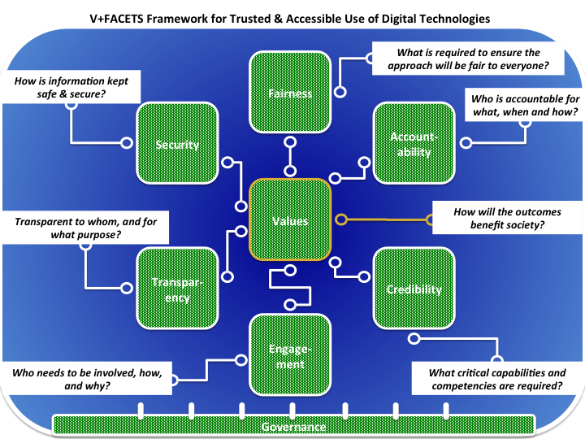

Figure9. An overview of the V+FACETS framework to build trust, accessibility and acceptance. Illustrative questions are shown.

References

Berkman Klein Center (2019). Introducing the Principled Artificial Intelligence project. https://cyber.harvard.edu/story/2019-06/introducing-principled-artificial-intelligence-project

Capita (2016). Trends vs Technologies 2016. A research report from Capita in partnership with Cisco

DLA Piper (2018). Is the era of the technology Wild West over? European Technology Index 2018. https://www.dlapiper.com/~/media/files/insights/publications/2018/12/european-technology-index-2018.pdf

Edwards, P. et al. (2019). Trust, engagement, information and social licence—insights from New Zealand. Environmental Research Letters 14, 024010. https://doi.org/10.1088/1748-9326/aaf33c

Gehman, J., Lefsrud, L.M., & Fast, S. (2017). Social license to operate: Legitimacy by another name? Canadian Public Administration 60, No. 2 (June 2017), 293–317.

Jenkins, K. (2018). ‘Can I see your social licence please?’ Policy Quarterly 14 (4 – November 2018), 27-35.

McKinsey (2018). Why digital strategies fail. McKinsey Quarterly, January 2018. https://www.mckinsey.com/business-functions/digital-mckinsey/our-insights/why-digital-strategies-fail

NESTA (2018). 10 (draft) principles for public sector use of algorithmic decision making. https://www.nesta.org.uk/blog/10-principles-for-public-sector-use-of-algorithmic-decision-making/

NZ Law Foundation (2019). Government use of artificial intelligence in New Zealand. Authors: Gavaghan, C. et al. https://www.cs.otago.ac.nz/research/ai/AI-Law/NZLF%20report.pdf

Parsons, R. & Moffat, K. 2014. “Constructing the meaning of social licence.” Social Epistemology 28: 340–63. doi:10.1080/02691728.2014.922645.

Social Investment Agency (2018). What you told us. Findings of the ‘Your voice, your data, your say’ engagement on social wellbeing and the protection and use of data. https://sia.govt.nz/assets/Uploads/what-you-told-us.pdf

Spiceworks (2018). Data snapshot: AI Chatbots and Intelligent Assistants in the Workplace. https://community.spiceworks.com/blog/2964-data-snapshot-ai-chatbots-and-intelligent-assistants-in-the-workplace

Statistics NZ (2018). A social licence approach to trust. https://www.stats.govt.nz/assets/Uploads/Corporate/Measuring-Stats-NZs-social-licence/a-social-licence-approach-to-trust.pdf

The Alan Turing Institute (2019). Understanding artificial intelligence ethics and safety. A guide for the responsible design and implementation of AI systems in the public sector. https://www.turing.ac.uk/sites/default/files/2019-06/understanding_artificial_intelligence_ethics_and_safety.pdf

UK Government Digital Service (2018). Technology innovation in government survey. https://www.gov.uk/government/publications/technology-innovation-in-government-survey/technology-innovation-in-government-survey

UK’s National Audit Office (2019). Challenges in using data
across government. https://www.nao.org.uk/wp-content/uploads/2019/06/Challenges-in-using-data-across-government.pdf

Wachter S., Mittelstadt B., Russell C.( 2018). Counterfactual Explanations without Opening the Black Box: Automated Decisions and the GDPR. Harvard Journal of Law & Technology. https://arxiv.org/abs/1711.00399

Walter, M & Suina, M. (2019). Indigenous data, indigenous methodologies and indigenous data sovereignty. International Journal of Social Research Methodology 22 (3), 233-24. Doi: https://doi.org/10.1080/13645579.2018.1531228

World Economic Forum (2019). 5 challenges for government adoption of AI. https://www.weforum.org/agenda/2019/08/artificial-intelligence-government-public-sector/

Annex 1 – Agencies and individuals consulted

Workshop (June):

ACC - Julia McConnell
DIA - Tiopira Piripi, Glen Thurston
IRD - Kristin Leslie
LINZ - Alison
MBIE - Lynda Kamstra
MoH - Eileen Duddy, Mary Crowe
MoJ - Vincent Pickering
MoT - Ralph Samuelson
MSD - Rosie Anderson, Kerrie O’Hara Pepper
NZDF - Pete Coleman, Dino Pericos
NZQA - Clarisse Lamarque
SIA - Kate Kolich
Statistics NZ - Craig Lange

Interviews:

Immigration NZ (MBIE) – Amanda Holt
IRD – Meade Perrin
MinEdu – Mark Horgan, Selena Smeaton
MfE – Steve Smith
MPI – Barry Polley
MPP – Terina Cowan
NZ Customs Service – Mat Black, Jason Moore
NZ Police – Rob Cochrane, Gaylene Rogers
NZTA – Derek Lyon, Nicola Bowler

Internet NZ – Ben Creet & Nicola Brown,
GCPO – Russell Cooke
University of Otago – Colin Gavaghan, James Maclaurin & Joy Liddicoat,
Victoria University – Miriam Lips,

Annex 2 – Selected international reports on emerging technologies

Accenture (2019). Technology vision 2019. The Post-Digital era is upon us. https://www.accenture.com/_acnmedia/pdf-94/accenture-techvision-2019-tech-trends-report.pdf

Commission Nationale Informatique & Libertés (2017). How can humans
Keep the upper hand? The ethical matters raised by algorithms and artificial intelligence. https://www.cnil.fr/sites/default/files/atoms/files/cnil_rapport_ai_gb_web.pdf

CSIRO (2019). Digital megatrends. https://www.data61.csiro.au/en/Our-Work/Future-Cities/Planning-sustainable-infrastructure/Digital-Megatrends-2019

Deloitte. Gov2020. The future of government in 2020. http://government-2020.dupress.com/

Deloitte (2019). Tech Trends 2019. Government and public services perspective
https://www2.deloitte.com/us/en/pages/public-sector/articles/government-tech-trends.html

Deloitte (2019). Government trends 2020. https://www2.deloitte.com/insights/us/en/industry/public-sector/government-trends.html

DLA Piper (2018). Is the era of the technology Wild West over? European Technology Index 2018. https://www.dlapiper.com/~/media/files/insights/publications/2018/12/european-technology-index-2018.pdf

Emerj (2019). AI in Government – Current AI Projects in the Public Sector. https://emerj.com/ai-sector-overviews/ai-government-current-ai-projects-public-sector/

EY-Mint (2019). Emerging Technologies: Changing how we live, work and play
https://www.ey.com/Publication/vwLUAssets/ey-mint-emerging-technologies-report-2019/$File/ey-mint-emerging-technologies-report-2019.pdf

Future Today Institute (2019). Tech trends 2019. https://futuretodayinstitute.com/2019-tech-trends/

IBM Centre for the Business of Government (2017). Seven drivers of change for governments. http://www.businessofgovernment.org/sites/default/files/Seven%20Drivers%20Transforming%20Government.pdf

McKinsey (2018). Why digital strategies fail. McKinsey Quarterly, January 2018. https://www.mckinsey.com/business-functions/digital-mckinsey/our-insights/why-digital-strategies-fail

McKinsey (2019). When governments turn to AI: Algorithms, trade-offs, and trust. https://www.mckinsey.com/industries/public-sector/our-insights/when-governments-turn-to-ai-algorithms-trade-offs-and-trust

NESTA. 10 (draft) principles for public sector use of algorithmic decision making
https://www.nesta.org.uk/blog/10-principles-for-public-sector-use-of-algorithmic-decision-making/

Pwc. The Essential Eight. Your guide to the emerging technologies revolutionizing business now. https://www.pwc.com/gx/en/issues/technology/essential-eight-technologies.html

Spiceworks (2019). Public Cloud Trends in 2019 and Beyond. https://community.spiceworks.com/blog/3208-public-cloud-trends-in-2019-and-beyond

UK Government Digital Service (2018). Technology innovation in government survey. https://www.gov.uk/government/publications/technology-innovation-in-government-survey/technology-innovation-in-government-survey

World Economic Forum (2017). 6 ways augmented reality can help governments see more clearly. https://www.weforum.org/agenda/2017/02/augmented-reality-smart-government/

World Economic Forum (2019). 5 challenges for government adoption of AI. https://www.weforum.org/agenda/2019/08/artificial-intelligence-government-public-sector/

Annex 3. Selected use cases of technologies by NZ government agencies

Current use
Purpose | Cloud computing | AI | Spatial computing | Encryption/ Blockchain | Autonomous systems | Robotics | GIS | 3D Printing | Other
Transact | Tax transactions
Manage | SAP tools & Contact Centre | Natural Language Processing for threat assessments of messages from public
Security |  |  |  | Encryption for secure data transfer
Knowledge |  |  |  |  |  |  | Mapping environments
Educate |  |  | VR for training staff
Recommend |  |  |  |  |  |  |  |  | MyACC – tracking claims (data analytics)
Communicate |  | Chatbot pilot trial
Match |  |  |  |  |  |  |  |  | Passport biometrics for facial recognition (data analytics)
Diagnose |  | Diagnostic imaging of mammograms
Prediction |  |  |  |  |  |  | Predicting land use changes
Decision-support |  |  |  |  | Drones for operational support |  |  | 3D printing from MRIs for pre-surgery analysis
Behavioural |  |  | VR for children having MRIs to reduce anxiety
Physical task
 | Cloud computing | AI | Spatial computing | Encryption/ Blockchain | Autonomous systems | Robotics | GIS | 3D Printing | Other

Future uses

Purpose | Cloud computing | AI | Spatial computing | Encryption/ Blockchain | Autonomous systems | Robotics | GIS | 3D Printing | Other
Transact |  |  |  |  |  |  |  |  | New payment systems for Visas, etc
Manage | Storage of images from baggage scans | Student assessments | Property maintenance
Security |  |  |  | 2 Factor analysis for identity management
Knowledge |  |  |  |  |  |  |  |  | Environmental monitoring & mapping
Educate |  |  | Injury prevention
Recommend |  | Pre-approval of payments
Communicate |  |  |  |  | Chatbots to support staff queries
Match |  | Facial recognition to verify identity
Diagnose
Prediction
Decision-support | Cloud-based risk assessment tools | Aid to passenger and freight risk assessments & profiling
Behavioural
Physical task |  |  |  |  | Medicine delivery (trials) | Food delivery robots |  | 3D printed prosthetics
 | Cloud computing | AI | Spatial computing | Encryption/ Blockchain | Autonomous systems | Robotics | GIS | 3D Printing | Other

Defined as electronic tools, systems and devices that generate, process and store data
https://www.digital.govt.nz/digital-government/digital-transformation/digital-inclusion/digital-inclusion-blueprint/
https://www.data.govt.nz/assets/Uploads/Algorithm-Assessment-Report-Oct-2018.pdf
https://www.gov.uk/government/publications/technology-innovation-in-government-survey/technology-innovation-in-government-survey
https://www.stats.govt.nz/assets/Uploads/Corporate/Measuring-Stats-NZs-social-licence/a-social-licence-approach-to-trust.pdf
https://sia.govt.nz/assets/Uploads/what-you-told-us.pdf
http://www.ssc.govt.nz/our-work/integrityandconduct/
https://en.wikipedia.org/wiki/SaveManapouricampaign
https://nzhistory.govt.nz/politics/nuclear-free-new-zealand/nuclear-free-zone
https://www.mfe.govt.nz/publications/hazards/report-royal-commission-genetic-modification
https://en.wikipedia.org/wiki/ToiTeTaiao:TheBioethicsCouncil
https://trusteddata.co.nz/
https://www.temanararaunga.maori.nz/
https://www.msd.govt.nz/documents/about-msd-and-our-work/work-programmes/initiatives/phrae/phrae-on-a-page.pdf
http://www.ssc.govt.nz/our-work/integrityandconduct/
https://clinic.cyber.harvard.edu/2019/06/07/introducing-the-principled-artificial-intelligence-project/
Understanding artificial intelligence ethics and safety (June 2019) - https://www.turing.ac.uk/sites/default/files/2019-06/understandingartificialintelligenceethicsandsafety.pdf
https://www.newscientist.com/article/2205779-creating-an-ai-can-be-five-times-worse-for-the-planet-than-a-car/
https://www.mpp.govt.nz/language-culture-and-identity/kapasa/
https://www.nesta.org.uk/blog/helping-cities-innovate-responsibly-ai/
Attributed to Madeleine Elish, Data & Society
See “Researcher Outlines How VR Data Collection Could Be Used Against You” https://uploadvr.com/report-vr-data-collection-stanford/

