Document purpose
This document outlines requirements for, and response to, an engagement of the HealthShare Regional IS architecture capability.

Problem statement
A target state and roadmap for a Data, Business Intelligence and Analytics capability is required to provide input to a business case to implement a first-phase capability implementation.
This paper focusses on business usage, functions and data sources (rather than technology and systems), and is intended to be a guide for conversation between clinical and corporate stakeholders to shape target state objectives and requirements.

Objectives

High level stakeholder objectives
Below are high level stakeholder objectives for a regional Data, Business Intelligence and Analytics capability. These are initial contacts and not an exhaustive list.
Objective | Stakeholders
Provide analysis data for regional clinical groups such as Child Health Action Group. | David Graham, Waikato DHB.
Provide input to innovation and research. | Charlie Stratton, BOP DHB.
Provide analysis insights to address MoH health equity objectives as well as data for System Level Measures and other relevant MoH measures as they arise. | Ruth Large, Waikato DHB.  Matt Valentine, BOP DHB.  Yariv Doron, Taranaki DHB.
Provide analysis data for DHB’s to wishing to undertake clinical improvements, service improvements and workforce improvements. | COOs
Clinical audit capability. | Quality and Risk
Provide data input to capacity planning. | Planning and Funding
Provide data input to financial management objectives. | CFOs
Financial audit and fraud detection measures. | CFOs?
Ensure privacy and security is managed at all times, with risks expressed and understood at the right level. | DHB Privacy officers  CISO for HealthShare
Ensure Data, Business Intelligence and Analytics capability aligns with regional objectives. | Data governance group  CIOs
Provide data to PHO’s for analysis, planning and feedback | Robin Milne representing BOPIS.  Reuben Kendall from Hauraki PHO

Input point - Regional Services Plan
The Regional Services Plan has 108 references to ‘data’ and an implied capability for analysis and reporting. The data references focus on varying levels of analysis to ensure that improvements can be targeted and measured.
An example, under the heading ‘Specific equity lens in Midland’:
Data management
- Regional Stakeholder Networks to identify data sets for analysis
- Ensure that analysis of data is undertaken and informs all projects undertaken in 2018-19
- Further analysis of current data sets to ascertain effectiveness of information provided.

Input point - MOH expectations
In the Minister of Health’s Letter of Expectations for district health boards and subsidiary entities for 2019 /20, there are many references to working with PHO’s and other key stakeholders across the health system to make improvements. These also imply data capture and measurement in order to demonstrate improvements.
Some examples include:
“I also want to see closer integration of primary health care with secondary and community care.”
“I expect you to continue to co-design and deliver initiatives to achieve progress on System Level Measures with primary health organisations (PHOs) and other key stakeholders.”
“Improving equity and wellbeing and delivering on several other expectations I am setting in this letter will not be possible without strong cross-sectoral collaboration.”
First steps along the journey to making improvements are measurements and insights, understanding the environment we are in now and then making coordinated change.

Input point – healthAlliance content
Two hA artefacts were explored:
- Northern Region Data Strategy and Roadmap Definition v07 06-08-2018
- ISSP Data Management Capability (DMC) Implementation Pack
Some relevant excerpts can be found in the appendix.

Data sources

Target architecture data sources brainstorming

Target state functional capability

Foundational elements
These foundational items underscore having a consistent and scalable sustainable capability that meets the needs of the stakeholders. They must be undertaken first in order to avoid costly rework and/or loss of trust in the capability.
Element / component | Description / deliverable
Regional data architecture approach | - Agreed data architecture principles and objectives  - Agreed vision and target architecture  - Review of Data Management Association International (DAMA International) framework as a basis for data architecture capability. See appendix section 5.1.2 for overview.
Regional data architecture roadmap | - Agreed timeline plan of capability delivery, with viewpoints of functional capability and platform / systems
Agreed data standards | - Data classification standards (considering sensitivity, asserted-by, trustworthiness as well as clinical and corporate records inputs)  - Data storage and federation (structured vs non-structured, replication vs federation), use of abstraction, configuration and control layer in ETL  - Metadata management  - Interoperability standards  - Data refresh rates / data timeliness  - Development standards to support quality data capture and storage
Data governance | - Data governance roles and responsibilities.  - Defined data ownership concept agreement, along with agreed capability and roles for data quality, data stewardship.  - Agreement for roles in signoff of rules and definitions  - Prioritisation of capability elements delivery  - Promote standards adoption / adherence
Privacy and security policy | - Agreed approach to data obfuscation  - Policy for data usage for research and analytics  - Consider consent agreements
Data sharing agreements | - Data sharing agreements with external entities providing and consuming data  - Agreements for those undertaking research

Base platform capability elements
The associated components below will be refine in the first phase (section 4.1). These building block components give the minimum viable product for the capability.
Element / component | Description / deliverable
Data quality services | - Capability for exception based monitoring of data quality, and solution with ownership to remediate  - Consider requirements for and solution around culture of data literacy
ETL engine | - Extract, transform and load engine, which may include managed file transfer service (with scheduling and workflow) as well as abstraction, configuration and control layer
Rules and definitions engine | - Exposed rules / definitions engine, with reports able to see definitions and rules, and view who is the business owner for the data.  - Consider a subscribe model where usage of data is tracked and impact of changes can be traced
Data storage platform | - Database platform solution which factors in cost, performance and storage size
Data warehouse / data lake platform | - Some form of analytical data store in a relational data warehouse structured format or a low-latency NoSQL technology, or a database that provides a metadata abstraction over data files in a distributed data store.
Support / services construct | - Right-sized support capability which aligns to stakeholder needs at a manageable cost
Reports portal | - Front-end portal for viewing and basic manipulation / drill-down of reports

Enhanced capability elements
These components deliver the full value of the solution through advanced integration and consumption through other platforms, and value-add visualisation and analysis.
Element / component | Description / deliverable
Dashboards | - Adaptive and simple visual display mechanism with drill-down for stakeholders
Machine learning / AI | - Intelligent analytics and trending capability with anomaly identification
Self-service analytics | - Ability for a broad set of data analysts to create reports and obtain value in a safe, reliable sustainable manner
API’s | - Interfaces to allow data input, manipulation and insight consumption from other applications and integration engines.
Operational data stores | - These provide near-real-time analysis of operational data and the ability to (together with other elements) deliver up to date insights at the point of care.
Predictive analytics / modelling | - Modelling for ‘what-if’ analysis and prediction on future state

Appendix

healthAlliance content - Northern Region Data Strategy and Roadmap Definition v07 06-08-2018: page 18
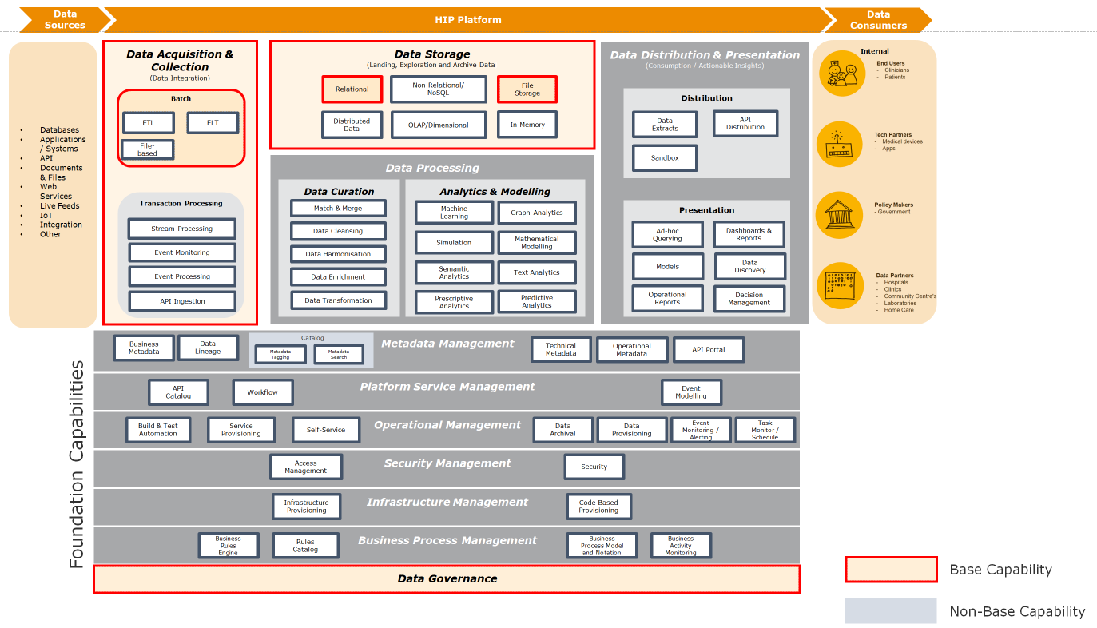

healthAlliance content – ISSP Data Management Capability (DMC) Implementation Pack: page22
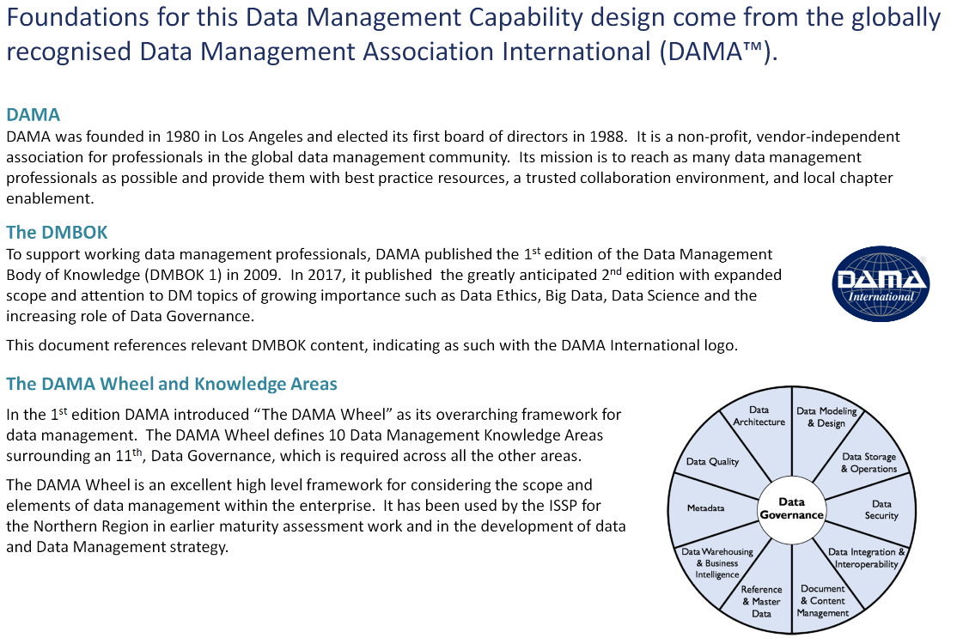

healthAlliance content – ISSP Data Management Capability (DMC) Implementation Pack: Page117
